Consumers Energy Announces Clean Energy Breakthrough Goal:
80 Percent Reduction in Carbon Emissions, Zero Coal by 2040
CEO Patti Poppe Says it’s a Stand for Protecting the Planet and People of Michigan

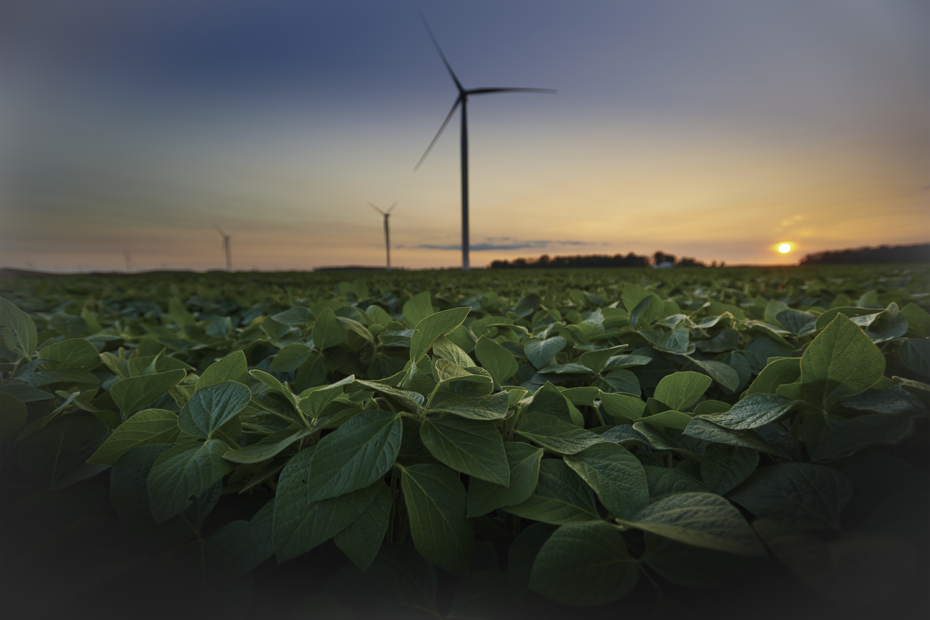
JACKSON, Mich., February 19, 2018 – Consumers Energy and CMS Energy today announced Consumers Energy’s plans to meet Michigan’s energy needs reducing carbon emissions by 80 percent and no longer using coal to generate electricity by 2040. The company also said today that more than 40 percent of the energy produced will come from renewable sources and energy storage by 2040.
In the past five years, Consumers Energy has created a cleaner, more sustainable energy future for the state by taking a leadership position in reducing air emissions, reducing water usage, saving landfill space and boosting the amount of renewable energy supplied to customers. This continued transformation to cleaner fuel sources is part of a long-term strategic commitment to protect the planet.
“Our actions speak louder than words and we have a track record of doing more than is required. Our actions to date have reduced our carbon intensity by 38 percent, reduced our water usage by 35 percent and avoided over one million cubic yards of landfill disposal. We are still not satisfied. The goals announced today represent our further commitment to leave Michigan far better than we found it, because we live here, too,” said Patti Poppe, President and CEO of Consumers Energy & CMS Energy.
The company also announced new 5-year environmental goals for Michigan water, waste and land, including:
- Water: save 1 billion gallons of water;
- Waste: reduce waste to landfills by 35 percent; and
- Land: enhance, restore or protect 5,000 acres of land in Michigan.
Consumers Energy has served Michigan with safe, reliable and affordable energy for more than 130 years, and boasts a strong track record of environmental stewardship. The company:
- Ranked as one of the Top 10 Greenest Companies in the Nation and the #1 company in Michigan in Newsweek’s annual rankings just last month. This recognition reflects Consumers Energy’s commitment to environmental principles that are good for the people of Michigan.
- Scored highest for sustainability performance among U.S. utility companies and ranked 16th among 195 global utilities, as assessed by Sustainalytics, for the second consecutive year.
- Began moving away from coal by closing seven of its twelve coal-fired generating plants in 2016 – more than any investor-owned utility that year, resulting in a 38 percent carbon intensity reduction from 2008 levels.
- Received the Governor’s 2017 Excellence in Recycling Award from the Michigan Department of Environmental Quality.
- Helped residential and business customers save over $1 billion with energy efficiency programs since 2009.
- Announced in 2017 a Large Customer Renewable Energy Tariff program which allows large job-providing companies who elect to generate 100 percent of their energy with renewable sources from Consumers Energy.
- Owns and operates two wind farms – the Lake Winds and Cross Winds energy parks – and operates two utility-scale solar projects at Western Michigan and Grand Valley State universities. In addition the company utilizes energy from the Apple Blossom wind park; and co-owns the Ludington Clean Pumped Storage facility, a hydroelectric plant on Lake Michigan.
- The company is also investing in modernizing its natural gas infrastructure across the state, which is more safely delivering energy to Michigan customers while reducing greenhouse gas emissions as gas is transported.
Consumers Energy is embracing a cleaner, leaner vision focused primarily on reducing energy usage and adding additional renewable energy sources, such as wind and solar. The strategic roadmap for reaching its clean energy goal by 2040 will be published later this year when the company files its Integrated Resource Plan (IRP) with the Michigan Public Service Commission.
“We’re proud and uniquely qualified to provide the strong leadership needed to protect our planet and our home state for decades to come,” added Poppe.
Consumers Energy, Michigan’s largest energy provider, is the principal subsidiary of CMS Energy (NYSE: CMS), providing natural gas and/or electricity to 6.7 million of the state’s 10 million residents in all 68 Lower Peninsula counties.
# # #
*This news release contains "forward-looking statements." The forward-looking statements are subject to risks and uncertainties that could cause CMS Energy’s and Consumers Energy’s results to differ materially. All forward-looking statements should be considered in the context of the risk and other factors detailed from time to time in CMS Energy's and Consumers Energy's Securities and Exchange Commission filings.

Media Contacts: Megan Brown, 517-788-6538 or Katie Carey, 517-788-2395
For more information about Consumers Energy, go to www.ConsumersEnergy.com.

Check out Consumers Energy on Social Media

.

