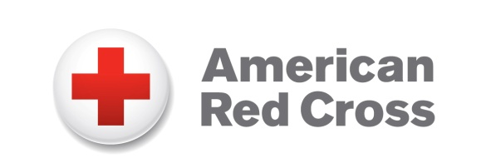
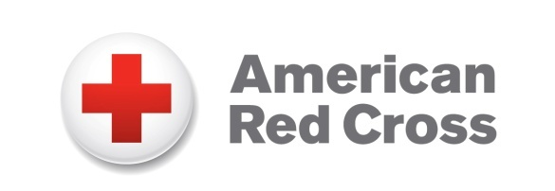
Blood Donation Opportunities
June 24-July 15, 2019
RedCrossBlood.org

Red Cross urges donors to fill Missing Types to prevent summer blood shortage

(June 24, 2019) — The _meric_n Red Cr_ss needs _l_ _d d_n_rs to bring back the missing A’s, B’s and O’s. A few missing letters may not seem like a big deal in a sentence, but for patients who need A, B, O and AB blood types, these missing letters mean life. The Red Cross urges donors of all blood types to give now to help prevent delays in medical care this summer.

Six years ago, doctors told Jacqueline Rogers' family that there wasn’t enough type O negative blood available to perform her open-heart surgery. This news that her surgery was postponed was scary for Jacqueline, just 8 at the time, who was born with a congenital heart disorder. “No blood means no surgery. I thought I was going to die.” Fortunately, blood donors stepped up, and Jacqueline’s surgery was successfully completed a week later.

To draw attention that blood types sometimes do go missing from hospital shelves, A’s, B’s and O’s began disappearing on June 11 from iconic brand logos, social media pages, signs and websites as part of the Missing Types campaign. The campaign is raising awareness of the need for more blood donors.

While thousands of blood donors have answered the call to fill the Missing Types, more donors are needed now to help ensure patients don’t have to wait for blood products. During the summer, especially around holidays like Independence Day, donations often don’t keep pace with patient needs. The Red Cross is thanking all those who come to donate July 1-6 with an exclusive Red Cross Missing Types T-shirt, while supplies last.

Make an appointment to donate blood by downloading the free Red Cross Blood Donor App, visiting RedCrossBlood.org or calling 1-800-RED CROSS (1-800-733-2767).

Upcoming blood donation opportunities June 24-July 15

Livingston

Howell
6/24/2019: 1 p.m. - 6:45 p.m., Howell Elks Club, 2830 E. Grand River Avenue
6/26/2019: 11:30 a.m. - 5:15 p.m., Livingston County American Red Cross, 1372 W. Grand River Avenue

Brighton
6/27/2019: 11 a.m. - 4:45 p.m., Preview Properties, 130 W. Grand River Avenue

Pinckney
6/28/2019: 12:30 p.m. - 6:15 p.m., Pinckney American Legion, 9807 Whitewood

Howell
7/1/2019: 1 p.m. - 6:45 p.m., Oak Grove United Methodist Church, 6686 Oak Grove Road
7/3/2019: 11 a.m. - 4:45 p.m., MediLodge, 3003 W Grand River
7/11/2019: 11 a.m. - 3:45 p.m., Saint Joseph Mercy Livingston Hospital, 620 Byron Road

Fowlerville
7/15/2019: 12 p.m. - 5:45 p.m., St Agnes Catholic Church, 855 E. Grand River Avenue

How to donate blood
Simply download the American Red Cross Blood Donor App, visit RedCrossBlood.org or call 1-800-RED CROSS (1-800-733-2767) to make an appointment or for more information. All blood types are needed to ensure a reliable supply for patients. A blood donor card or driver’s license or two other forms of identification are required at check-in. Individuals who are 17 years of age in most states (16 with parental consent where allowed by state law), weigh at least 110 pounds and are in generally good health may be eligible to donate blood. High school students and other donors 18 years of age and younger also have to meet certain height and weight requirements.

Blood and platelet donors can save time at their next donation by using RapidPass® to complete their pre-donation reading and health history questionnaire online, on the day of their donation, before arriving at the blood drive. To get started, follow the instructions at RedCrossBlood.org/RapidPass or use the Blood Donor App.

About the American Red Cross
The American Red Cross shelters, feeds and provides emotional support to victims of disasters; supplies about 40% of the nation’s blood; teaches skills that save lives; provides international humanitarian aid; and supports military members and their families. The Red Cross is a not-for-profit organization that depends on volunteers and the generosity of the American public to perform its mission. For more information, please visit redcross.org or cruzrojaamericana.org, or visit us on Twitter at @RedCross.

###

