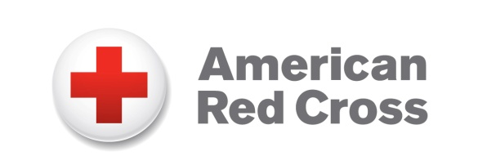
Media Statement

Todd Kulman, 517-896-4929 www.redcross.org
The following statement regarding the cancellation of a blood drive at Huron Valley Guns can be attributed to Todd Kulman, communications manager, Southeastern Michigan Blood Services Region:
“The American Red Cross appreciates the intent of Huron Valley Guns to hold a blood drive this weekend to help patients in need and we apologize to the blood drive sponsor and donors for the late cancellation of that drive earlier this week.
The Red Cross is committed to maintaining a weapons-free environment in which our employees and volunteers safely and securely conduct Red Cross business and fulfill its humanitarian mission. Red Cross policy prohibits staff, donors or partners from possessing, transferring, storing, selling or using weapons of any type, whether openly or concealed, at any Red Cross facility regardless of whether or not the individual or organization has a federal or state license or permit to possess the weapon.
This policy does not prohibit the Red Cross from holding a blood drive outside this location, as long as the staff, donors or partners are not possessing, storing or using weapons at the blood drive. We did not effectively communicate our policy to the blood drive sponsor, and as we began preparations to hold the drive we faced a number of logistical and promotional challenges that ultimately made it unfeasible to move forward. We are committed to improving this process as we organize drives in the future.

Over the upcoming weeks, there are a number of opportunities to donate blood in the community and we encourage individuals to schedule a blood donation appointment at www.redcrossblood.org.”

