NEW Volunteer Opportunity!

Are you interested in assisting with a brand new and exciting food rescue initiative with Gleaners Community Food Bank?
Would you like a volunteer opportunity that fits your schedule and availability?
With the Gleaners Middle Mile initiative, volunteers will pick up food directly from donors and drop off food donations to local food pantries, soup kitchens and schools!

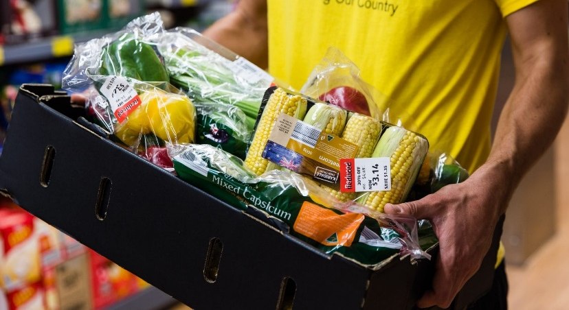
Volunteer Requirements:
- Pass a background check
- Have a minimum of 100k/300k liability insurance coverage
- Have a working cellphone (smartphone) to accept volunteer opportunities
- Attend an in-person training session
- Be willing to drive within Livingston County

Call or email Roni Lundy to find out more about the Middle Mile Initiative!
Roni Lundy
rlundy@gcfb.org
313-923-3535 ext. 331
