LIVINGSTON COUNTY
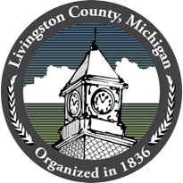
Livingston County, Michigan
2300 E Grand River Ave. - Howell MI 48843

Livingston County Deeply Saddened By Passing Of County Administrator Ken Hinton

(October 21, 2019 - Howell, Michigan) Livingston County is deeply saddened by the passing of County Administrator, Ken Hinton. Ken had been a valued leader at Livingston County since 2015 and will be greatly missed. Our thoughts and prayers are with Ken’s family as they go through this difficult time.

Ken’s passing has deeply affected us all, but Livingston County’s employees will come together as a team to ensure County Administration functions continue. Deputy County Administrator, Cindy Catanach, will assume the role of acting County Administrator.

###
Contact:
Donald S. Parker
Dsparker22@hotmail.com
517-546-3520

