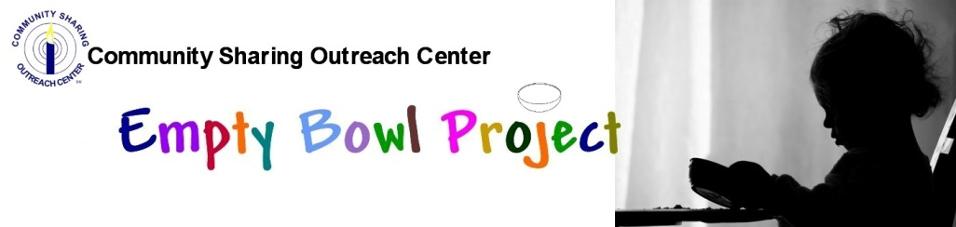
Would you like some good soup on a Fall Sunday?
Would you like to be part of the solution to a really good cause?
Come join us for 15 different delicious soups you can try!
Split Pea with Ham Americus Coney & Grill
Wisconsin Beer Cheese with Sausage Bakers of Milford
Lobster Bisque Colasanti’s Market
Double Baked Potato Cleary University Culinary Academy
Pasta Fagioli Coratti’s on Main
Dill Pickle Czapski’s
Stuffed Green pepper D’s Café
Mexican Tortilla Duke’s of Highland
Minestrone Highland House
Mushroom Bisque The Root Resturant
Chicken & Shrimp Gumbo Schoolcraft College Culinary
Maryland Crab Sparkie’s Bar 7 Grill
Southwest Chicken, Corn & Poblano US Foods
Pumpkin Bisque Hector & Jimmy’s

Go to our website for more information:
www.community-sharing.org/fundraisers/empty-bowl-project/

