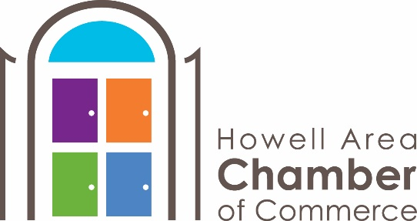

FOR IMMEDIATE RELEASE
CONTACT: Santino Mattioli, smattioli@howell.org

New Howell Chamber’s Morning Program Focuses on We ARE Livingston

The Howell Area Chamber of Commerce has delivered a facelift to its well-known morning program Good Morning Livingston. The informational morning event has been rebranded as We ARE Livingston. Program enhancements focus more on hot issues, and universally beneficial expertise. Topics range from cyber security to the future of our regional education systems. This month’s program, set for Tuesday, November 12th, features Keynote Speaker Dr. Regina Banks-Hall, Chair of Graduate & Professional Studies for Cleary University. Dr. Bank-Hall will be focusing on the generational characteristics and how-to best utilize generational knowledge when leading and managing a team in the workplace. Education, work habits and even the benefits employees look for differ from generation to generation; and with several generations active in the workplace, it can be a challenge to navigate. Discover the best way to communicate and lead the diverse groups that make up your business.

Other program enhancements include a rotating venue at member businesses through all of Livingston county, new breakfast options, and an opportunity to maximize networking with additional time offered before the presentations begin.

Join the Howell Chamber this month at 7:45 am at Citizens Insurance Agency, 808 N. Highlander Way Howell, MI 48843, and learn what makes the generations different to better lead them together.

###

