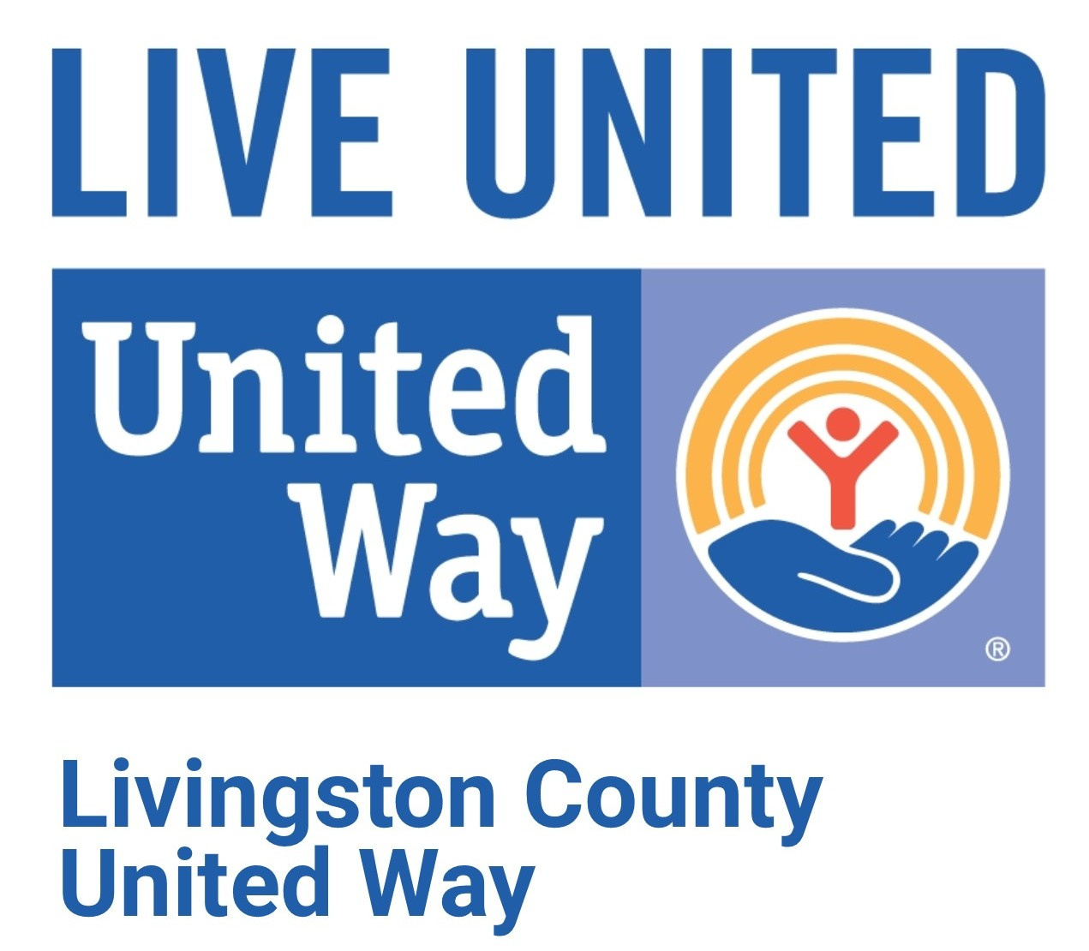
2980 Dorr Rd.
Brighton, MI 48116
810-494-3000

FOR IMMEDIATE RELEASE

Date: Tuesday, November 26, 2019

From: Terri Hillier-Romankewiz, Development / Marketing Director

Re: United Way’s 12th Annual Matching Money Monday is Dec. 9

Donations to the Livingston County United Way on Monday, December 9, will be matched up to total funds available!

Matching Money Monday is the single largest one-day fundraiser in Livingston County!

All donations raised from Matching Money Monday will go directly to help our local working families struggling to put food on their tables, keeping their lights & heat on, and a roof over their heads!

In addition to giving online at www.lcunitedway.org or by phone (810-494-3000), residents are encouraged to donate in person at any of these collection sites during regular business hours:

Brighton Area:
Livingston County United Way, 2980 Dorr Road, Brighton 7am-7pm (complimentary homemade cookies, hot coffee and cocoa)
- New this year, consider taking the kids to get outside for some physical activity at the sledding hill across the street at Genoa Township Sledding Hill. Teach our youth the importance of donating! Any donation size is appreciated! We will have a nice warm area in our building with hot coca and coloring activities for the kids.

- First National Bank: 9911 E Grand River, 9am-4pm
- First National Bank: 8080 Challis Rd, 9am-4pm
- Grace and Porta Benefits: 7219 Grand River Ave, 8am-5pm
- Greater Brighton Area Chamber of Commerce: 218 E Grand River Ave, 9am-5pm

Fowlerville Area:
- First National Bank: 760 S Grand Ave, 9am-4pm
- Katie Pikkarainen State Farm Insurance: 215 E Grand Ave, 8:30am-5:30pm

Hartland Area:
- Emagine Theater: 10495 Hartland Rd, 9:30am-7pm (FREE small popcorn with donation)
- First National Bank: 10700 E Highland Rd, 9am-4pm
- Hartland Area Chamber of Commerce: 9525 E Highland Rd, 9am-2pm
- Hartland Insurance Agency: 2532 N Old 23, 8:30am-5pm

Howell Area:
- First National Bank: 101 E Grand River, 9am-4pm
- First National Bank: 2400 W Grand River, 9am-4pm
- First National Bank: 4299 E Grand River, 9am-4pm
- Howell Area Chamber of Commerce: 123 E Washington St, 9am-5pm
- Jonna’s Market: (both locations), 8am-6pm (FREE piece of peperoni pizza with donation)

Whitmore Lake Area:
- First National Bank: 9975 E M36, 9am-4pm

Matching Money Monday is possible through these generous sponsors: Howell Rotary’s Tour de Livingston, Anonymous Sponsors, LCUW Past & Present Board Members, Ravago (Randy Rudisill Leadership Match), Culver’s, Chemical Bank, Fifth Third Bank, First Presbyterian Church of Brighton and General Motors Milford Proving Ground.

To learn more about the work of Livingston County United Way and how to get involved or donate, call 810-494-3000, visit www.lcunitedway.org or social media accounts @lcunitedway.

# # #

