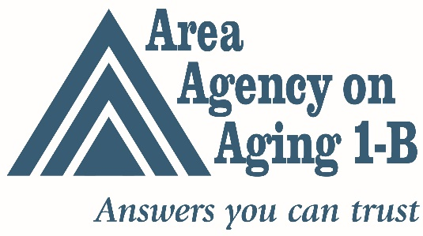
FOR IMMEDIATE RELEASE
Contact: Julie Edgar: 248-262-9966/jedgar@aaa1b.org
New Study Identifies Senior Social Isolation as a Public Health Issue, Calls for More Investment in Social Programming
LIVINGSTON COUNTY -- One in four Livingston County seniors say they would like more social contact with friends, neighbors and relatives, according to a recent survey conducted for the Area Agency on Aging 1-B (AAA 1-B). The findings also suggest an estimated 2,000 seniors in the county have no one they can confide in or count on for understanding and advice.
The findings are significant: senior social isolation, often referred to as loneliness or lack of social connectedness, has been identified as a national public health issue. Loneliness has been a found to be a contributing factor in fatal conditions such as heart disease and poses health risks that are comparable to obesity and smoking 15 cigarettes a day.
“The study is intended to provide data on indicators of social isolation, and document how receptive older adults are to the various services and solutions that Livingston County organizations offer to isolated seniors,” says Jim McGuire, director of research for the AAA 1-B. “We found that one in 13 of Livingston County’s 50,000 seniors have no friends of family nearby whom they can ask for help.”
AAA 1-B commissioned a needs assessment survey last summer to find out what seniors in each of the six counties it serves need to live independently, safely and happily. The results overall were consistent: Between 1 in 4 and 1 in 5 seniors crave more social contact.
Social isolation is a national problem that is often associated with higher risk of elderly suicide, elder abuse and financial exploitation. An AARP Public Policy Institute study found that social isolation adds almost $7 billion per year to the annual cost of Medicare, primarily due to longer hospital stays. While rural, low income, and younger seniors (ages 60-74) are more likely to report not having enough social contact, the differences are not statistically significant.
Some barriers to socialization mentioned by survey participants—like illness—were hard to overcome. But other obstacles (lack of awareness of available programs, affordability of programs, or lack of transportation to attend programs) could be addressed by strengthening funding of existing local organizations such as senior centers and Livingston Essential Transportation Service (LETS). .
“Knowing that some barriers are easily addressed is good news,” said McGuire. “We have some great organizations in Livingston County that may be able to alleviate some of these issues if given additional support.” AAA 1-B recommends addressing senior social isolation by investing more resources in social, wellness and volunteer programming.
- 30 -
About the Survey
Mitchell Research & Communications conducted a quantitative study (telephone survey) to determine attitudes and opinions on a wide variety of issues facing 60+ residents of Livingston, Macomb, Monroe, Oakland, St. Clair and Washtenaw counties.
The telephone survey of 292 Livingston County residents 60 years and older was conducted August 21-26, 2019, and has a margin of error of + or – 5.73% at the 95% level of confidence. A telephone list containing landline and cellphone numbers for all 60+ residents in Livingston County was used.
The graph below is an estimation of the number of Livingston County seniors likely facing specific barriers based on our survey data and current Livingston County 60 and older data from the Southeast Michigan Council of Governments population survey of 2020.

