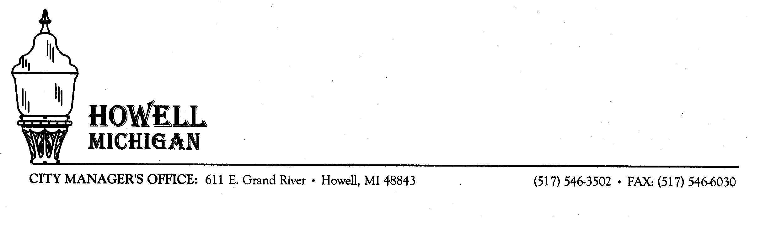
July 27, 2020
Department of Public Services 150 Marion Street · Howell, MI 48843 · (517) 546-7510 · FAX: (517)546-6019

Dear Resident,

As you may be aware, the Barnard Center located at 415 N Barnard, is in a bad state of disrepair and is scheduled to be demolished. An asbestos survey was performed this past January and it identified asbestos within the main building as well as in the storage building located on the property.

Regal Rigging and Demolition of Howell, was recently awarded the demolition contract. They are a licensed asbestos abatement contractor and will be performing the abatement as well as the demolition. Once the demolition is complete, the contractor will grade the lot to match the surrounding area and place seed in order to prevent soil erosion.

The contractor is currently in the process of performing interior work / abatement in preparation for the demolition. We are currently in the process of scheduling utility (gas, electric, water) disconnects. It is anticipated that the utility disconnects could be performed in 2 to 4 weeks. Once the utilities are disconnected, the contractor anticipates 2 to 3 weeks for demolition of the buildings and restoration of the lot.

Should you have any questions throughout this process, please contact the Department of Public Works at 517-546-7510.

Sincerely,

Matt Davis
DPW Superintendent
City of Howell

