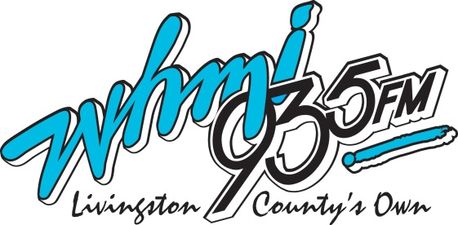
LIVINGSTON COUNTY ESTIMATES AMERICAN RECOVERY PLAN
Brighton city | Livingston County | $ 755,942
Brighton township | Livingston County | $ 1,862,701
Cohoctah township | Livingston County | $ 329,885
Conway township | Livingston County | $ 356,446
Deerfield township | Livingston County | $ 422,403
Genoa township | Livingston County | $ 2,042,899
Green Oak township | Livingston County | $ 1,873,661
Hamburg township | Livingston County | $ 2,151,906
Handy township | Livingston County | $ 837,500
Hartland township | Livingston County | $ 1,497,862
Howell city | Livingston County | $ 948,284
Howell township | Livingston County | $ 713,879
Iosco township | Livingston County | $ 381,130
Marion township | Livingston County | $ 1,102,415
Oceola township | Livingston County | $ 1,462,514
Putnam township | Livingston County | $ 833,649
Tyrone township | Livingston County | $ 1,042,876
Unadilla township | Livingston County | $ 341,339
 | TOTAL | $ 18,957,289
Livingston County | Michigan | $ 37,236,248

