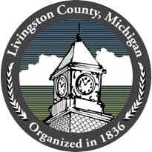

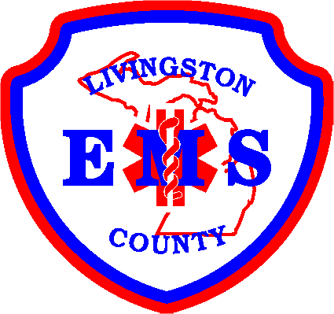

LIVINGSTON COUNTY EMS
Livingston County, Michigan
1911 Tooley Rd. - Howell MI 48843

FOR IMMEDIATE RELEASE:
MAY 19,2021

Livingston County Honors Frontline Heroes During Michigan EMS Recognition Week

HOWELL, Mich. – Livingston County is honoring its frontline heroes for their lifesaving work as Michigan celebrates EMS Recognition Week. May 16-22 was proclaimed Michigan EMS Recognition Week to thank Michigan’s emergency medical service personnel for their lifesaving work on the frontlines of the pandemic.

“We have an amazing staff of EMS professionals here in Livingston County,” said EMS Director, David Feldpausch. “I am extremely proud of our team and how quickly they adapted to everything that has been asked of them over the last year. They continuously step up to ensure the needs of the community are met, often at the sacrifice of their family and personal lives. Livingston County is very fortunate to have such a dedicated group of compassionate EMS providers.”

Livingston County’s EMS Department continuously goes above and beyond the call of duty, and the challenges of the last year were no exception. From implementing extra safety precautions and disinfecting protocols to safely care for patients in emergencies, whether related to COVID or not, our EMS professionals demonstrated their tireless devotion. The 101 heroes who work for EMS make it possible to serve our community 24 hours a day, 365 days a year. Livingston County EMS receives more than 19,000 request for service a year and is the sole provider of prehospital emergency services in our area. We’re lucky to have some of the greatest people in the State of Michigan constantly ensuring that emergency services are available to our County at all times. Thank You, Livingston County EMS!

###
Contact:
David Feldpausch, Director
Livingston County EMS
517-546-6220
dfeldpausch@livgov.com

