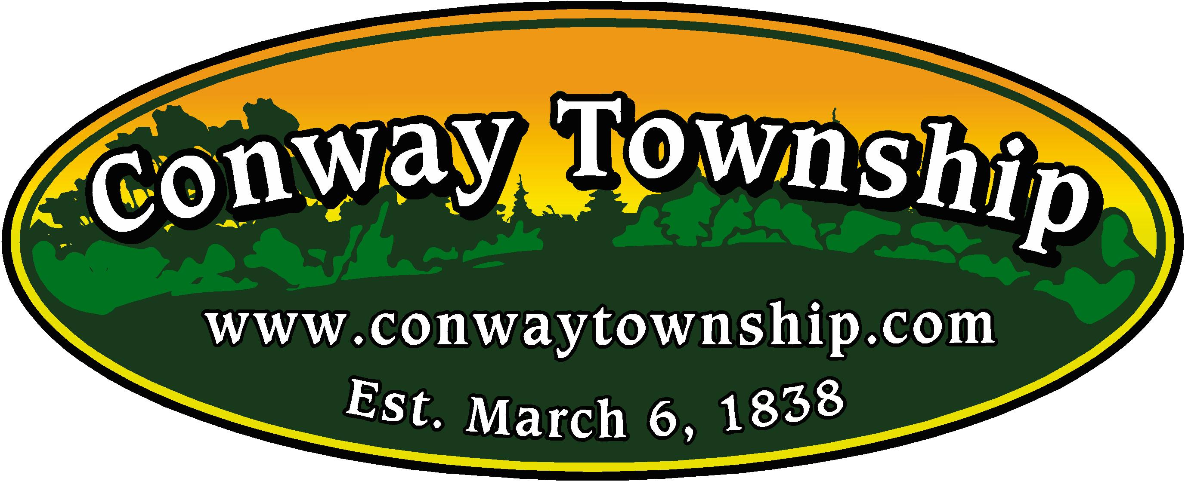
Conway Township
8015 N. Fowlerville Road
PO Box 1157
Fowlerville MI 48836
Phone 517-223-0358
Fax 517-223-0533

July 29, 2021

PRESS RELEASE

LAND USE APPLICATION FOR THE LUKE BRYAN FARM TOUR CONCERT SCHEDULED FOR SEPTEMBER 18, 2021, AT KUBIAK FARMS IN CONWAY TOWNSHIP, LIVINGSTON COUNTY, MICHIGAN, IS BEING CONSIDERED AND UNDER REVIEW BY CONWAY TOWNSHIP.

On July 20, 2021, the Conway Township Board voted to engage the Township Attorney to send relevant communications to event coordinator Dennis Freeman of Freeman Enterprises, acting on behalf of Row Crop LLC, dba Luke Bryan, and Kubiak Farms Property, LLC, regarding the September 18, 2021, Farm Tour event planned to take place within the Township at Kubiak Farms. At the time of the Board directive, the Township Zoning Administrator had not received the necessary supporting documentation to issue the required land use permit for the event and it was not immediately apparent to the Township that this information was forthcoming. Since the Board meeting and the Attorney’s communications, Conway Township is pleased to report it has received several of the requested documents and there is a plan for provision of the remainder of the needed information in a timely manner. Given the current trajectory of the application submissions and initial feedback from Livingston County officials, it appears the Township will have a completed application in the near future and be in a position issue a decision on the land use permit in advance of the planned event.

For Immediate Release
For additional information, call the Conway Township Hall at the number listed above.

