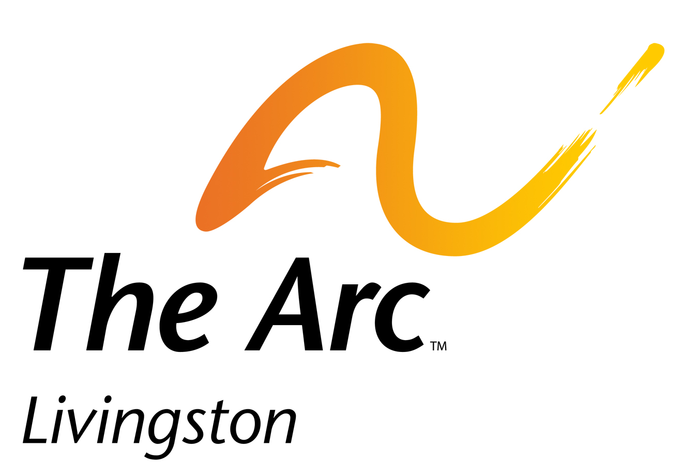

2980 Dorr Rd,
Brighton, MI 48116
(517) 546-1228

October 5, 2021

For Immediate Release:

The Arc Livingston is pleased to announce the hiring of Carol Lynn Taggart, of Howell, as Executive Director. Taggart will be replacing Anne Richardson, who will be retiring in December, 2021.

Taggart comes to The Arc with a diverse background in the non-profit sector and was most recently the Director of Advancement at Michigan Humanities in Okemos. She and her family have lived in Livingston County for 18 years, 9 of which was spent at Cromaine Library in Hartland as the Marketing and Development Manager.

Carol is looking forward to being an agent of change, enlightenment, and education through her work at The Arc Livingston. Taggart said, “I’m thrilled to be a part of this outstanding organization that has done such wonderful work in Livingston County. Anne has been an outstanding leader, and I am honored to be selected as the next Executive Director. I can’t wait to support the people of Livingston County through this important work!”

The Arc Livingston exists to empower persons with developmental disabilities and their families to ensure that they as citizens are valued, and that they can participate fully in and contribute to the life of their community. For more information on advocacy support and other services offered through The Arc Livingston, contact the office at 517-546-1228, follow them on Facebook at https://www.facebook.com/Thearclivingston/ or visit the organization’s website at www.arclivingston.org .



The Arc of Livingston exists to empower persons with developmental disabilities and their families to assure that they as citizens are valued, and that they can participate fully in, and contribute to the life of their community.

