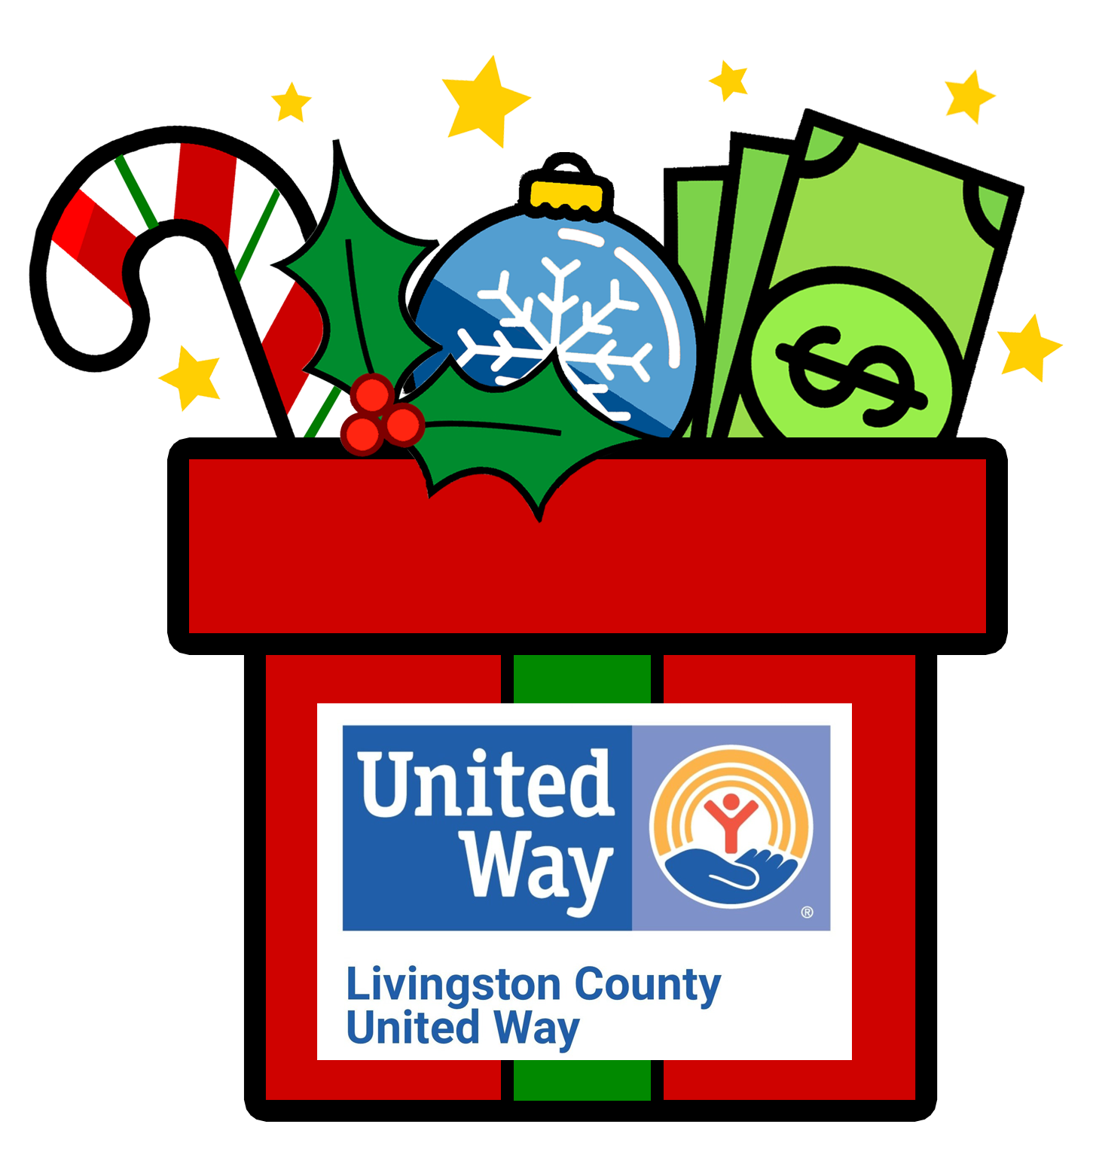

FOR IMMEDIATE RELEASE

Date: Tuesday, November 23, 2021

From: Anne Rennie, Executive Director

Re: United Way’s 14th Annual Matching Money Monday is Dec. 6

It is hard to believe that we are almost through 2021. At Livingston County United Way we are neck-deep in preparing for our community’s needs in 2022 and raising money to support those needs. This year’s Matching Money Monday event is more important than ever as many of our partner companies have been hit hard with loss of employees and material shortages. Many of our community-funded agencies are still struggling to support increased needs lingering from the pandemic and the high cost of living is further burdening ALICE (Asset Limited Income Constrained Employed) families. Please consider joining us on this very special day as we work to lift our neighbors back onto solid ground. All donations received on Monday, December 6, will be matched, dollar for dollar, up to total funds available! Matching Money Monday is the single largest one-day fundraiser in Livingston County!

All donations raised from Matching Money Monday go directly to help our local working families, many of whom are struggling to put food on their tables and keep their homes warm with heat and lights. This really is your Christmas Gift to the Community!

Have you ever wondered how matching work? It is from the generosity of amazing sponsors who go above and beyond to cover the match each year. Matching Money Monday 2021 is possible through these generous sponsors: Howell Rotary’s Tour de Livingston, Ascension, General Motors Milford Proving Ground, Fifth Third Bank, Bob Maxey Ford, EctoHR, Redi-Wall, The Musch Family, The Horan Family, Executive Wealth Management, Wilson Marine, LCUW Past & Present Board Members and Anonymous Sponsors.

Please consider supporting our Livingston County Families! You can donate online at www.lcunitedway.org , by phone (810-494-3000), or drop off your donation to Livingston County United Way’s office at 2980 Dorr Rd, Brighton, MI 48116. This year you are welcome to come on in the building or you can drive up and we will come out to you! Either way, we will still have cookies safely prepared and individually wrapped for each person!

To learn more about the work of Livingston County United Way and how to get involved or donate, call 810-494-3000, visit www.lcunitedway.org or social media accounts@lcunitedway. # # #

