LIVINGSTON COUNTY, MICHIGAN
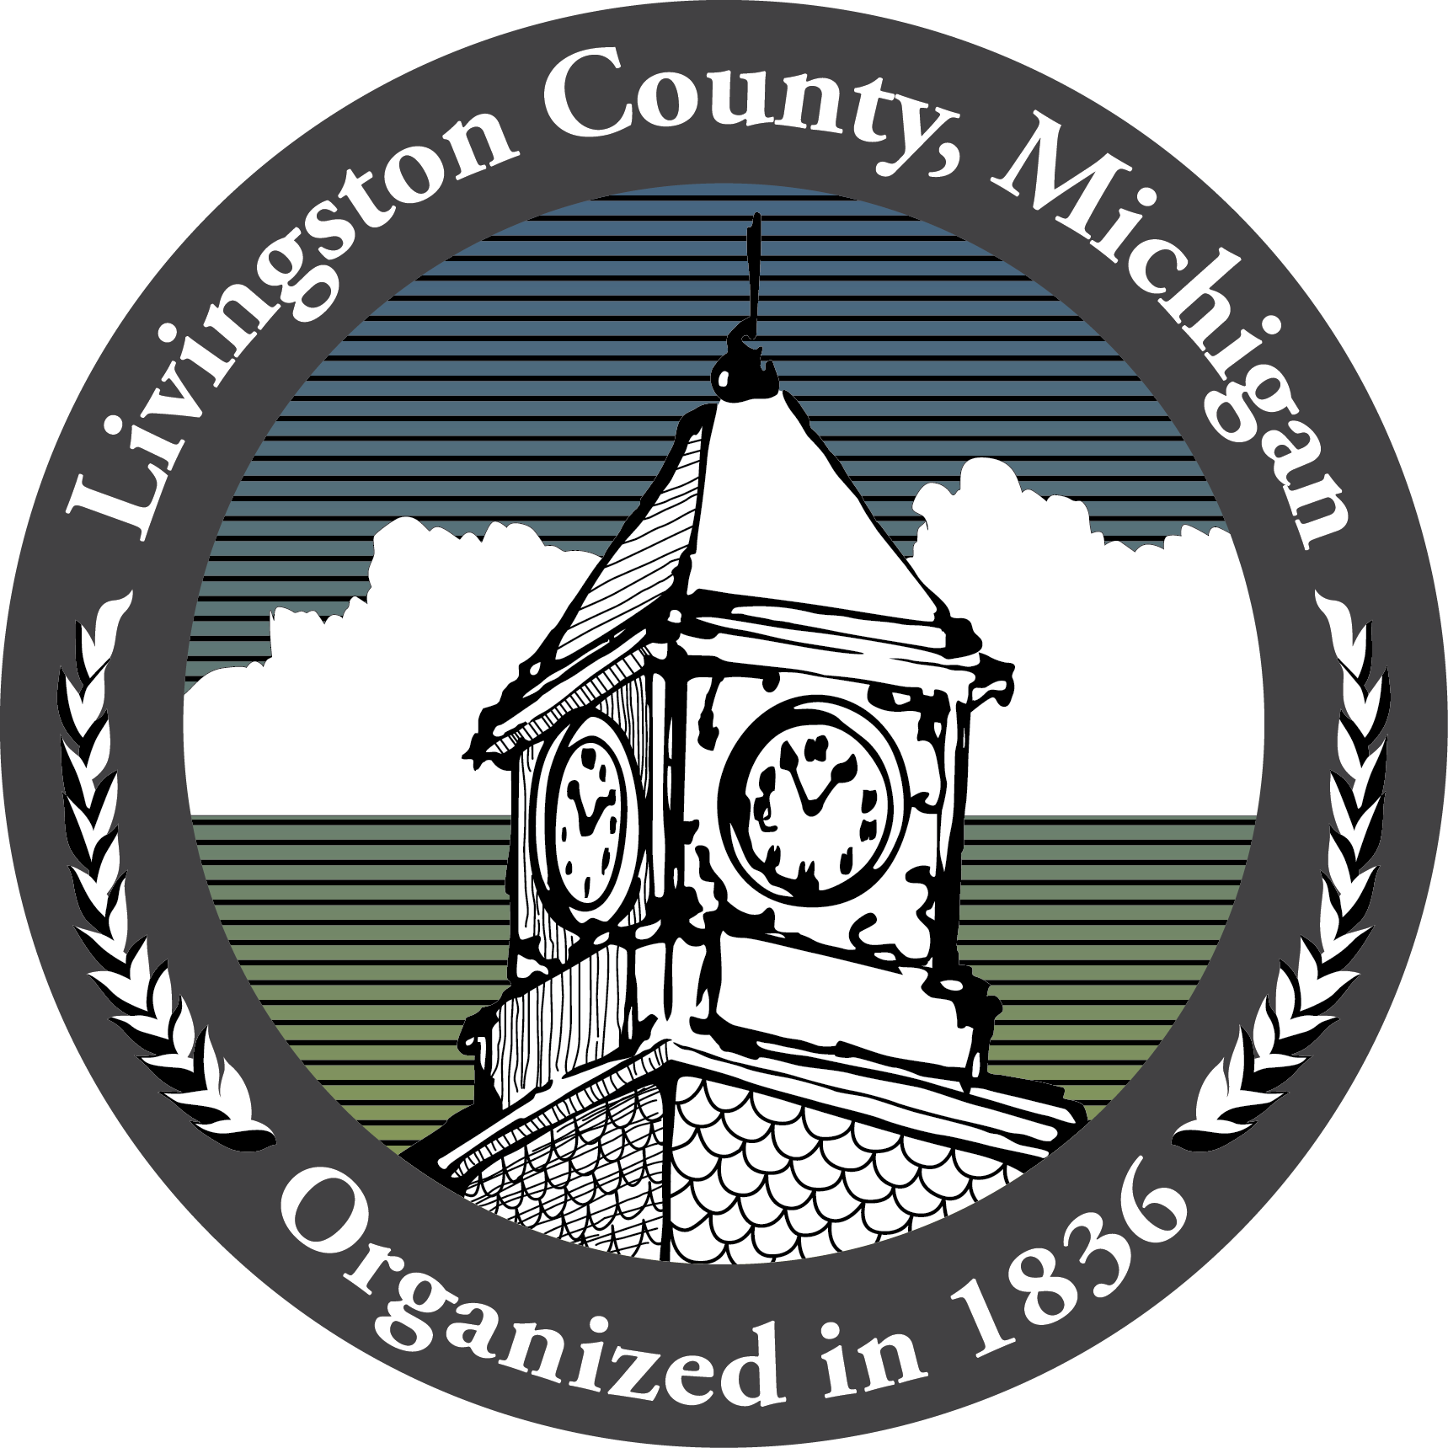
Livingston County Administration
304 E. Grand River Avenue - Howell MI 48843

FOR IMMEDIATE RELASE
December 15, 2021

Livingston County’s Broadband Survey Is Coming To A Close And Residents Are Encouraged To Participate

HOWELL, Mich. – Livingston County is encouraging its residents to take their quick, easy, and secure Broadband Survey. The response period for the survey is quickly coming to an end and all those who are interested in helping the County plan for a better-connected future are asked to participate. The County’s Board of Commissioners knows that many of our residents experience frustrating barriers when it comes to Internet connectivity. In an effort to better understand Internet connectivity within our area and to explore broadband expansion options, the County has partnered with Merit Network to conduct a survey of our residents.

“Our broadband survey is still open and we continue to receive helpful planning responses from our residents and businesses. We have been very successful so far, but the more responses we get, the greater the accuracy for future planning phases,” said Chief Information Officer Kristoffer Tobbe. The County hopes to receive as many resident responses as possible to ensure they have a clear picture of service in our area. Some areas that would benefit from additional resident responses include Cohoctah, Deerfield, Conway, Putnam, Marion, and Hamburg Townships. Residents in these areas can make a large impact by completing the survey and asking their neighbors to do so as well.

To date, the County’s response rate for the survey is setting records. Over 4,500 households in our community have taken the survey, which made the responses the County received statistically significant earlier on in the survey timeline than expected. "We have been so impressed by the citizen engagement in Livingston County. Granular, accurate and unbiased data is fundamental to national broadband expansion and local community engagement. The combination of citizen driven data and empowered local decision makers is essential to sound decision making for the federal investment in infrastructure having a sound impact. The County and its leaders recognize that and have been working hard to contribute," said Charlotte Bewersdorff, Vice President for Community Engagement at Merit Network.

The survey is open until January 1, 2022, and available at https://www.merit.edu/livgov/. To learn more about the survey, residents can visit the County’s website at https://www.livgov.com/communications/Pages/Resident-Broadband-Survey.aspx. “Please take five minutes to fill out the survey and take the speed test between now and January 1st, 2022. Your response is important for the future of connectivity in our County,” says Tobbe. “A big ‘thank you’ goes out to all those who ready have taken the survey. Your help is deeply appreciated!”

About The Michigan Moonshot and the Merit Network:
The Michigan Moonshot is a collective call to action which aims to bridge the digital divide in Michigan. Stakeholders include Merit Network, the nation’s longest-running research and education network, the Quello Center at Michigan State University and M-Lab, the largest open Internet measurement platform in the world. Learn more about the Michigan Moonshot at Merit.edu/Moonshot

###

