Howell Area Parks and Recreation Authority
Oceola Community Center
1661 N. Latson Rd.
Howell, MI 48843

For Immediate Release
Please contact the Oceola Community Center with questions at
at (517) 546-0693.
Community Survey
June 3rd, 2022, at 7:00 P.M.

Howell Recreation has created a community survey to reach members of the Howell area to grow our understanding of what the community would like to see from Howell Recreation.
We would like to see what needs attention, what we do well with, and what new things the citizens of Howell would like to see in their area.
Please share this any way you can. Below is a link to the survey that you would include in your post.
Thank you for helping us grow with Howell.
Survey Link: https://www.surveymonkey.com/r/72LXZNQ
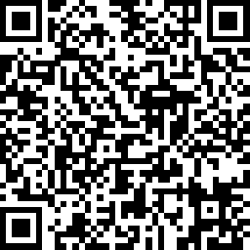
Survey QR Code:

Contact us: parksandrec@howellrecreation.org
517-546-0693 ext. 0
# # #

The Howell Area Parks & Recreation Authority was formed in 2006 and serves residents in the City of Howell, Oceola, Genoa, Marion, and Howell Township. Our mission is to bring communities together to enrich lives by promoting active and healthy lifestyles.

