LIVINGSTON COUNTY, MICHIGAN
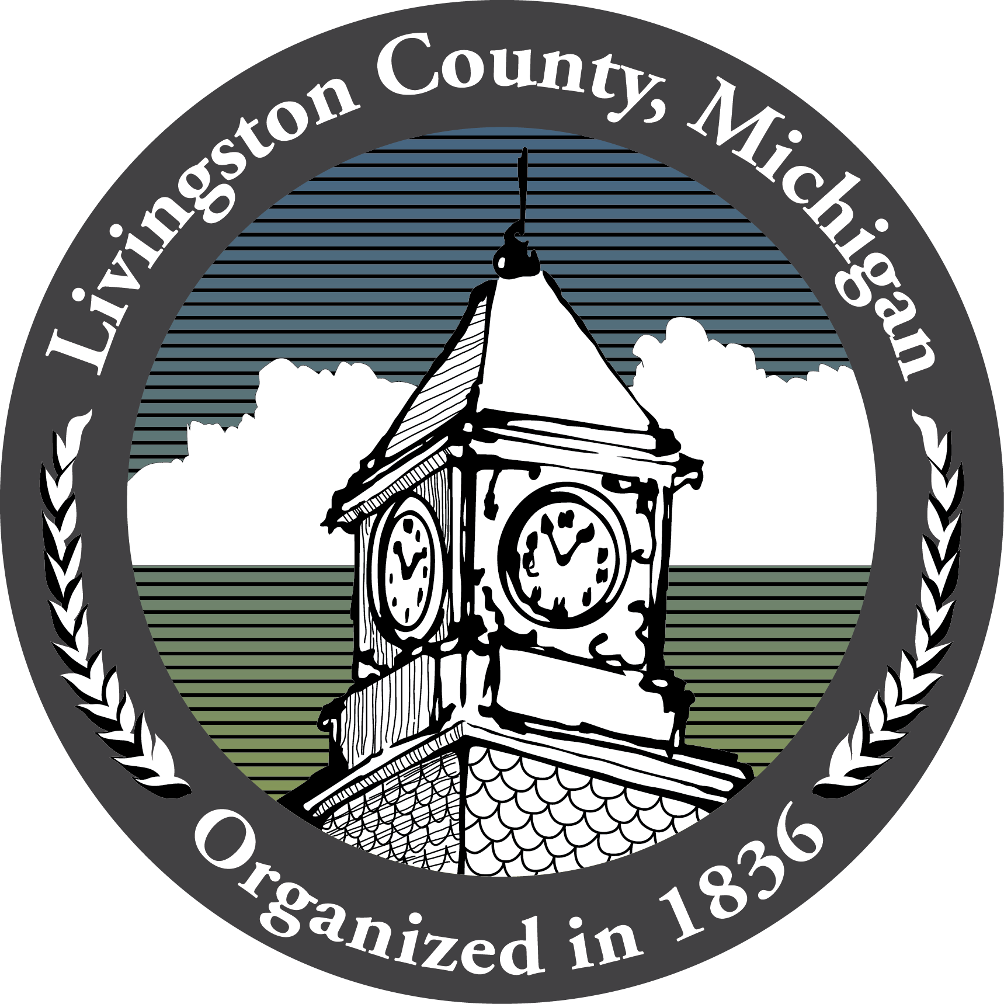
Livingston County Fiscal Services
304 E. Grand River Avenue - Suite 202 - Howell MI 48843

FOR IMMEDIATE RELASE
July 26, 2022

Livingston County Receives Fifth GFOA Budget Award

HOWELL, Mich. – For the fifth year in a row, Livingston County is proud to announce that they have received the Government Finance Officers Association’s (GFOA) Distinguished Budget Presentation Award for their 2022 Operating Budget Document. Fiscal responsibility continues to be a high priority and this award reflects the County’s commitment to meet the highest principals of government budgeting. In fact, the GFOA’s Distinguished Budget Presentation Awards Program is the only national awards program in governmental budgeting. In order to receive this prestigious award, Livingston County satisfied nationally recognized guidelines for effective budget presentation. The 2022 Operating Budget Document received outstanding ratings in a majority of the rating categories and mandatory criteria.

“Our Budget Book is a great source of information about Livingston County’s budget and the activities of each department. For it to be recognized with the GFOA Distinguished Budget Presentation Award for a fifth year in a row is a tremendous accomplishment. The finished product is a credit to the many staff members involved with the process, with special recognition to our Fiscal Services and Communications departments,” said County Administrator, Nathan Burd.

Each year, Elected Officials, Courts, and departments devote hours of thoughtful consideration and professional foresight to the budgeting process and creation of the annual budget. The County’s 2022 Budget Book not only reflects the budget process, it also serves as a policy document, a financial plan, an operations plan, and a communication device. The public is invited to take a look at the County’s 2022 Budget Document at https://www.livgov.com/fiscal-services/Documents/Budget/_2022-Budget-Book-FINAL-Digital.pdf.

There are over 1,700 participants in GFOA’s Budget Award Program, and each has pioneered efforts to improve the quality of budgeting while providing an excellent example for other governments throughout the nation. Livingston County is honored to join the Budget Award recipients as they are highlighted on GFOA’s website, http://www.gfoa.org/award-programs/distinguished-budget-presentation-award-program-budget-awards-program.

###

Contact:
Cindy Arbanas, Finance Officer
Livingston County
517-546-8720
carbanas@livgov.com

