FOR IMMEDIATE RELEASE
Executive Committee
President
Brian Jonckheere
Vice President
Jeff Blagg
Secretary/Treasurer
Gregory Clum
Past President
Steve Williams
Community Investments Council Chairperson
Katie Pikkarainen
Publicity & Education
Chairperson
Rena M. Pomaville
Campaign Co-Chairpersons
Rick Todd
Barbara Walker

DIRECTORS
Carole Damon
Greg Hillier
Erin MacGregor
Carolyn Nelson
John O’Malley
Steve Parker
Trevor Peitz
Cynthia Penabaker
Teresa Plummer
Melissa Schwartz
Jeff Warder
Ethics officer
Darlene McManus

LEGAL COUNSEL
Athena Bacalis

EXECUTIVE DIRECTOR
Nancy A. Rosso

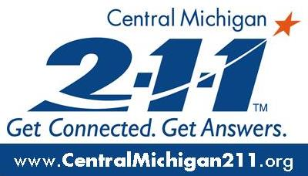

Date: August 30, 2022
Livingston County
United Way

From: Nicole Mandziuk, Development and Marketing Director

Re: Livingston County United Way 2022 Campaign is starting

Livingston County United Way is kicking off our 2022 Campaign this week and we need your help! Since the pandemic, our community agencies continue to report escalated struggles, with families in need having greatly increased. The stress of inflated gas prices and food costs will cause these additional needs in our county to persist into 2023.

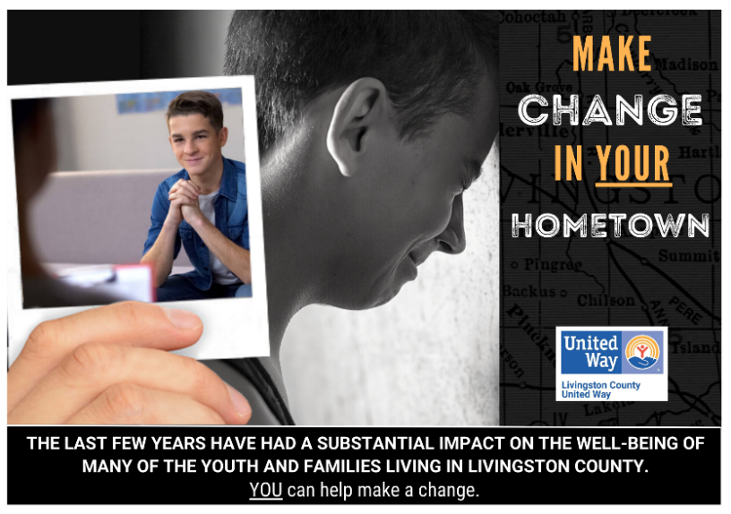
We need your support in order to bridge this gap for local families and cannot do it without the donations we will receive during this campaign year. We will direct your donations straight into the hands of the people that need it most by working with local agencies to identify current and critical needs, vetting those agencies through financial and reporting measures to ensure they are good stewards of the dollars we give them and then supporting their work to ensure our neighbors can get the support they need, when they need it.

As explained by James Johnston, Vice-President at Bank of Ann Arbor, “United Way is the best way to get the most impact for your community”.
Listed below are the agencies we are funding in 2022-23, with some providing multiple programs.
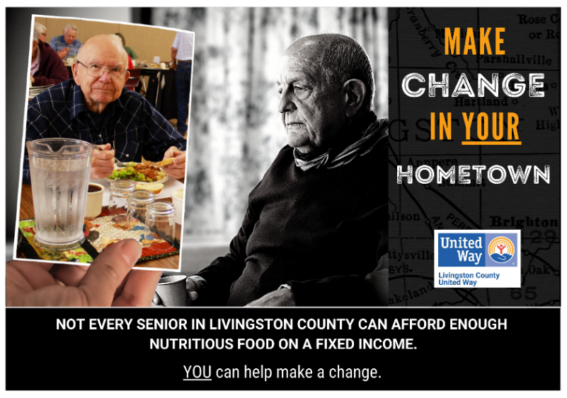
- LACASA
- Livingston Educational Service Agency (LESA)
- Livingston County Catholic Charities
- Childcare Network
- Gleaners
- The Salvation Army
- Meals on Wheels
- Livingston Family Center
- Habitat for Humanity
- Work Skills Corporation
- Community Catalysts
- The Arc of Livingston
- Hartland Senior Center
- Howell Senior Center
- Howell Teen Center
- Legal Services of South Central Michigan
- Pantry Network Funds - Bountiful Harvest Pantry, Family Impact Center Pantry, St. Joseph Pantry, Farley Hill Elementary Pantry, SonRise Pantry and Dora’s Cupboard
- MSU Extension
- Recovery Advocates in Livingston (RAIL)
- Oakland Livingston Human Service Agency (OLHSA)
- VINA Community Dental
- Pregnancy Help Clinic
- Community Connect
- Homeless Awareness Week
From the ALICE Report data, we still have 24% of our neighbors who are working, but not making ends meet. That is about 1 in 4! Your donations last year supported all 51 programs that are helping to keep our neighbors healthy, housed and safe.
As we embark on the 2022 Campaign, our goal is to ensure we have enough funds to keep everyone in our community healthy, whether that is a young person with mental health needs, a family struggling with basic needs or even an older adult limited by their fixed income, together we can make change in our hometowns.
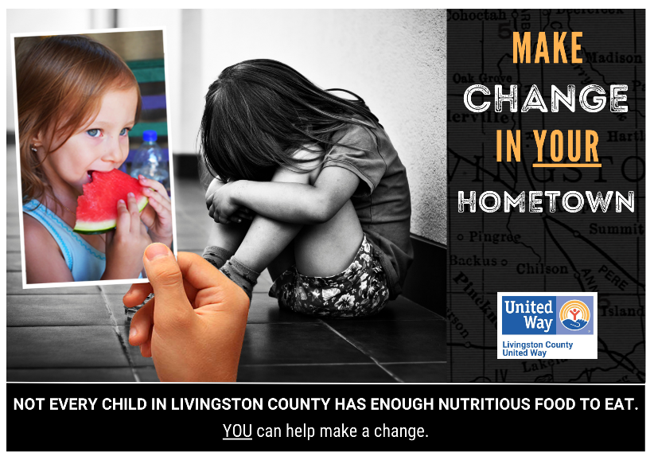
So we ask you to please consider donating to the United Way Campaign. If you work outside of the county, please make sure to designate your donation back to Livingston County in order to make a difference where you live.
Donating is easy:
- Go to www.lcunitedway.org and select the Donate button
- Mail to 2980 Dorr Road, Brighton. 48116
If you have questions or need more information, please reach out to Nicole Mandziuk at nmandziuk@lcunitedway.org

2980 Dorr Road, Brighton, Michigan 48116 · 810-494-3000 · Fax 810-494-3004 · lcuw@lcunitedway.org

