FOR IMMEDIATE RELEASE

Date: September 25, 2022

From: Jamie Kotzian, Rotary Member, Tour De Livingston Committee member

Re: Tour de Livingston (TDL)

Rotary Club of Howell is proud to present the 15th annual Tour de Livingston! All proceeds from this event go to support local hardworking families via the Livingston County United Way Basic Needs Programs.

**The Event**: The Tour de Livingston ride will take place on October 9th beginning and ending at the Howell Highschool Freshman Campus located at 411 N Highlander Way. Riders will have their choice of 8 different routes to determine their desired fall color path! Pre-Registration is open and will end on Friday, October 7 at 11:59 PM. Onsite registration starts on the date of the event at 7:00 AM. The first 100 riders will receive a $25 gift card to Hometown Bicycles! A nutritious breakfast will be provided upon arrival at registration and appropriate safety protocols will be followed. TDL T-shirts will be available for purchase on the day of the event. For more information or to register for this event please visit <https://www.tourdelivingston.org/>.

**Jersey Rider Info**: Sign up to be a 2022 Jersey Rider! Raise $300 or more and receive a complimentary rider registration and a commemorative Tour de Livingston Jersey! Jersey Riders should register with the code (JERSEYCODE) and then follow the Jersey Rider Fundraising link to begin raising money. All Jersey Riders will receive a $45 gist card to Hometown Bicycles! <https://myhometownbicycles.com/>

Check out the 2022 Jersey pictured below!

Directions for becoming a Jersey Rider: <https://www.tourdelivingston.org/wp-content/uploads/2022/07/Jersey-Rider-Flyer-with-instructions-2022_v2.pdf>

**Virtual Rider Info**: If you cannot participate on the day of the event, please check out the TDL Virtual Rider option! The Virtual Rider registration fee is $30 and will be used as a donation that will help the local community. Virtual Riders will participate and ride on their own schedule and are able to choose their own routes, ride day, and distance. Riders are encouraged to take pictures to be shared during their rides which can be posted along with a note on the TDL Facebook page <https://www.facebook.com/Tour.de.Livingston>. To register for the Virtual Ride please follow the regular registration link found on the TDL website. This is a great option to have fun and support a great cause at the same time!

Please help us spread the word and share this event with your friends & family! It will be a great day to enjoy scenic bike routes all while raising funds for the Livingston County United Way!

If you have any questions about the Tour De Livingston event, please reach out to Jamie Kotzian at [Jkotzian@wbmi.com](mailto:Jkotzian@wbmi.com) or (989) 640-0679.

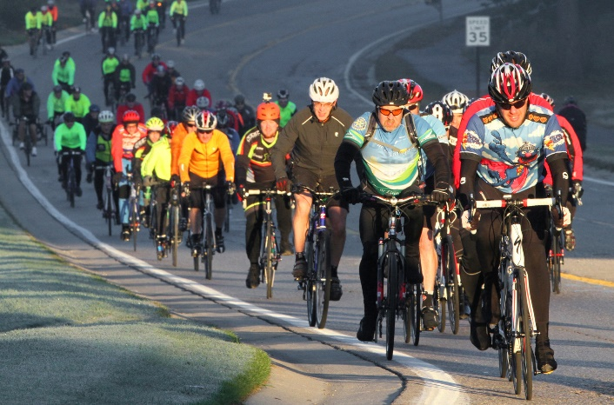

2980 Dorr Road, Brighton, Michigan 48116 · 810-494-3000 · Fax 810-494-3004 · lcuw@lcunitedway.org

2980 Dorr Road, Brighton, Michigan 48116 · 810-494-3000 · Fax 810-494-3004 · lcuw@lcunitedway.org

2980 Dorr Road, Brighton, Michigan 48116 · 810-494-3000 · Fax 810-494-3004 · lcuw@lcunitedway.org