LIVINGSTON COUNTY, MICHIGAN
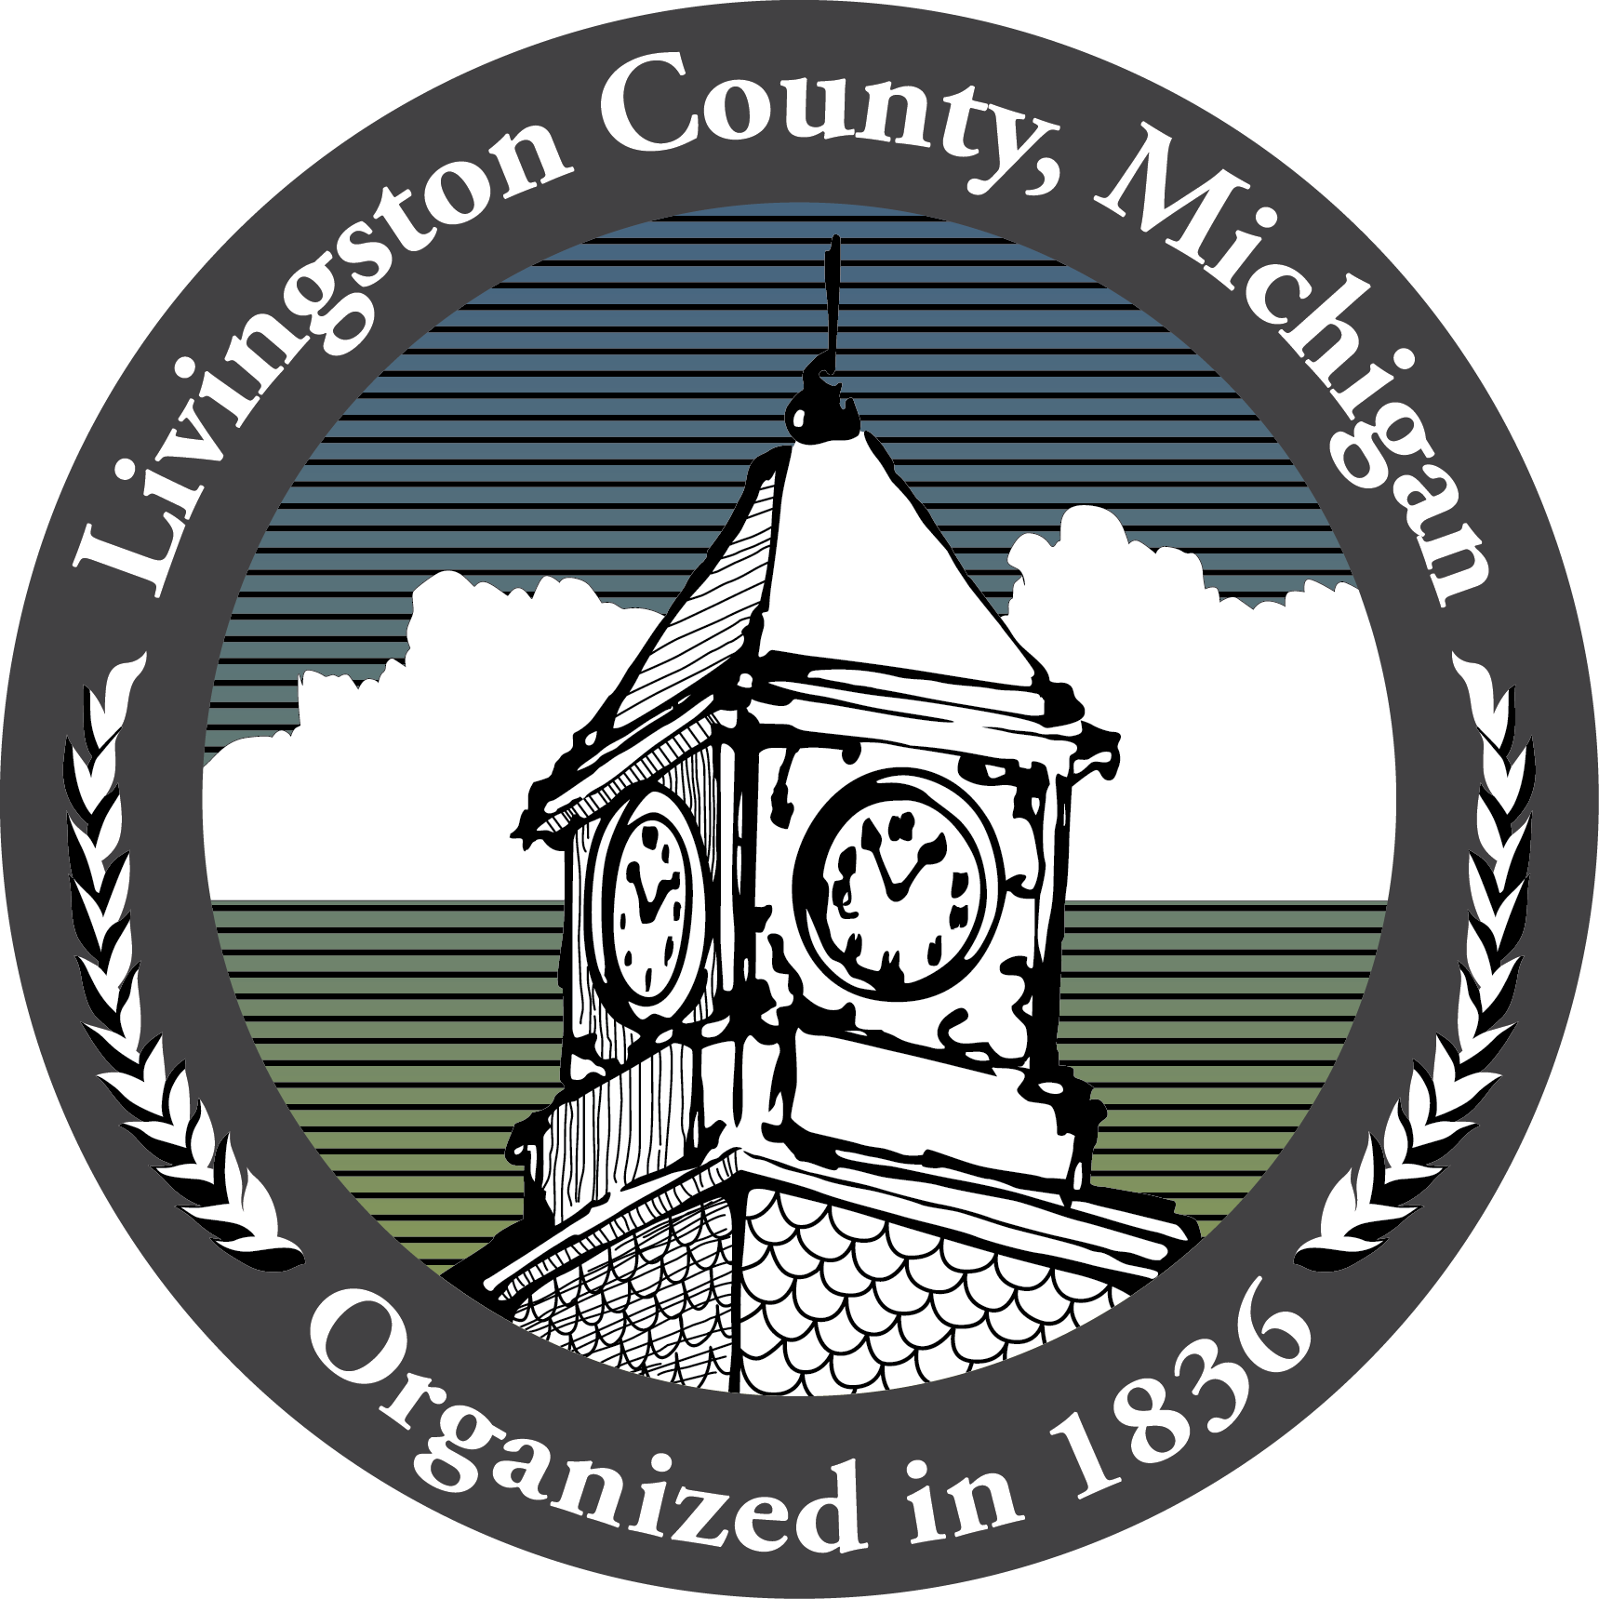

Veterans Services
1420 Lawson Dr. - Howell MI 48843

FOR IMMEDIATE RELASE
September 27, 2022

Livingston County Veteran Services Millage: What You Need To Know

HOWELL, Mich. – In the upcoming November 8th election, Livingston County residents will find an operational millage that would raise funds to support improving services for veterans on their ballots. In June 2022 the Livingston County Board of Commissioners approved ballot language for the proposal, which if passed, would assess 0.1127 mils for six years and generate slightly over $1 million per year, if levied, to provide support for veterans and their dependents in our community.

To learn more about the proposal, Veteran Services invites residents to visit their website, where they have created a “2022 Millage Proposal” section. The site can be accessed by visiting https://www.livgov.com/veterans/ and clicking on “Veterans Services Millage Proposal” banner. The site contains third party analysis of the proposal, the official ballot language, and a list of FAQs, which will help answer most questions about the proposal. If you have a question that has not been addressed, the department welcomes the public to email them at veterans@livgov.com. Questions and answers will be added to the FAQ list periodically.

What The Veteran Services Program Provides
The Veteran Services Program is dedicated to providing services and programs to over 12,000 veterans residing in Livingston County. Services include:
- Assistance in navigating the claims filing process with the Federal Government for injuries or illness, veterans’ pensions, death benefits, and survivor benefits.
- Case management and ongoing support for VA benefit recipients.
- Filing and processing of Livingston County burial allowances.
- Financial assistance for indigent veterans and their dependents.
- Transportation from veterans’ place of residence to medical appointments.
- Memorial Day flags and grave markers.

Areas Of Growing Need
Veteran Services have seen an increase in request for the following:
- Financial assistance for anything from food and gas to home repairs and utility bills.
- Mental health evaluation services.
- Burial benefits and legacy planning services.
An Operational Millage
- The 0.1127 mill millage, if passed, would be levied by Livingston County from 2022 through 2027.
- The millage would cost the owner of a home with a market value of $170,000 about $10 a year.

Millage Funding
Funding provided by the millage would be dedicated to the Veteran Services Department to provide services such as;
- Additional staff to provide greater benefits counseling.
- Increased financial relief, including increased burial benefits.
- Increased outreach to Livingston County’s veterans, including education of what benefits are available and how the Department can help veterans access these benefits.
- Expansion of transportation services for medical appointments within a 50-mile radius.
- Maintenance of the Department’s new expanded facility and increasing its use as a community center for veterans and their families.

###

Contact:
Ramon Baca, Veteran Services Director
Livingston County
517-546-6338
rbaca@livgov.com

