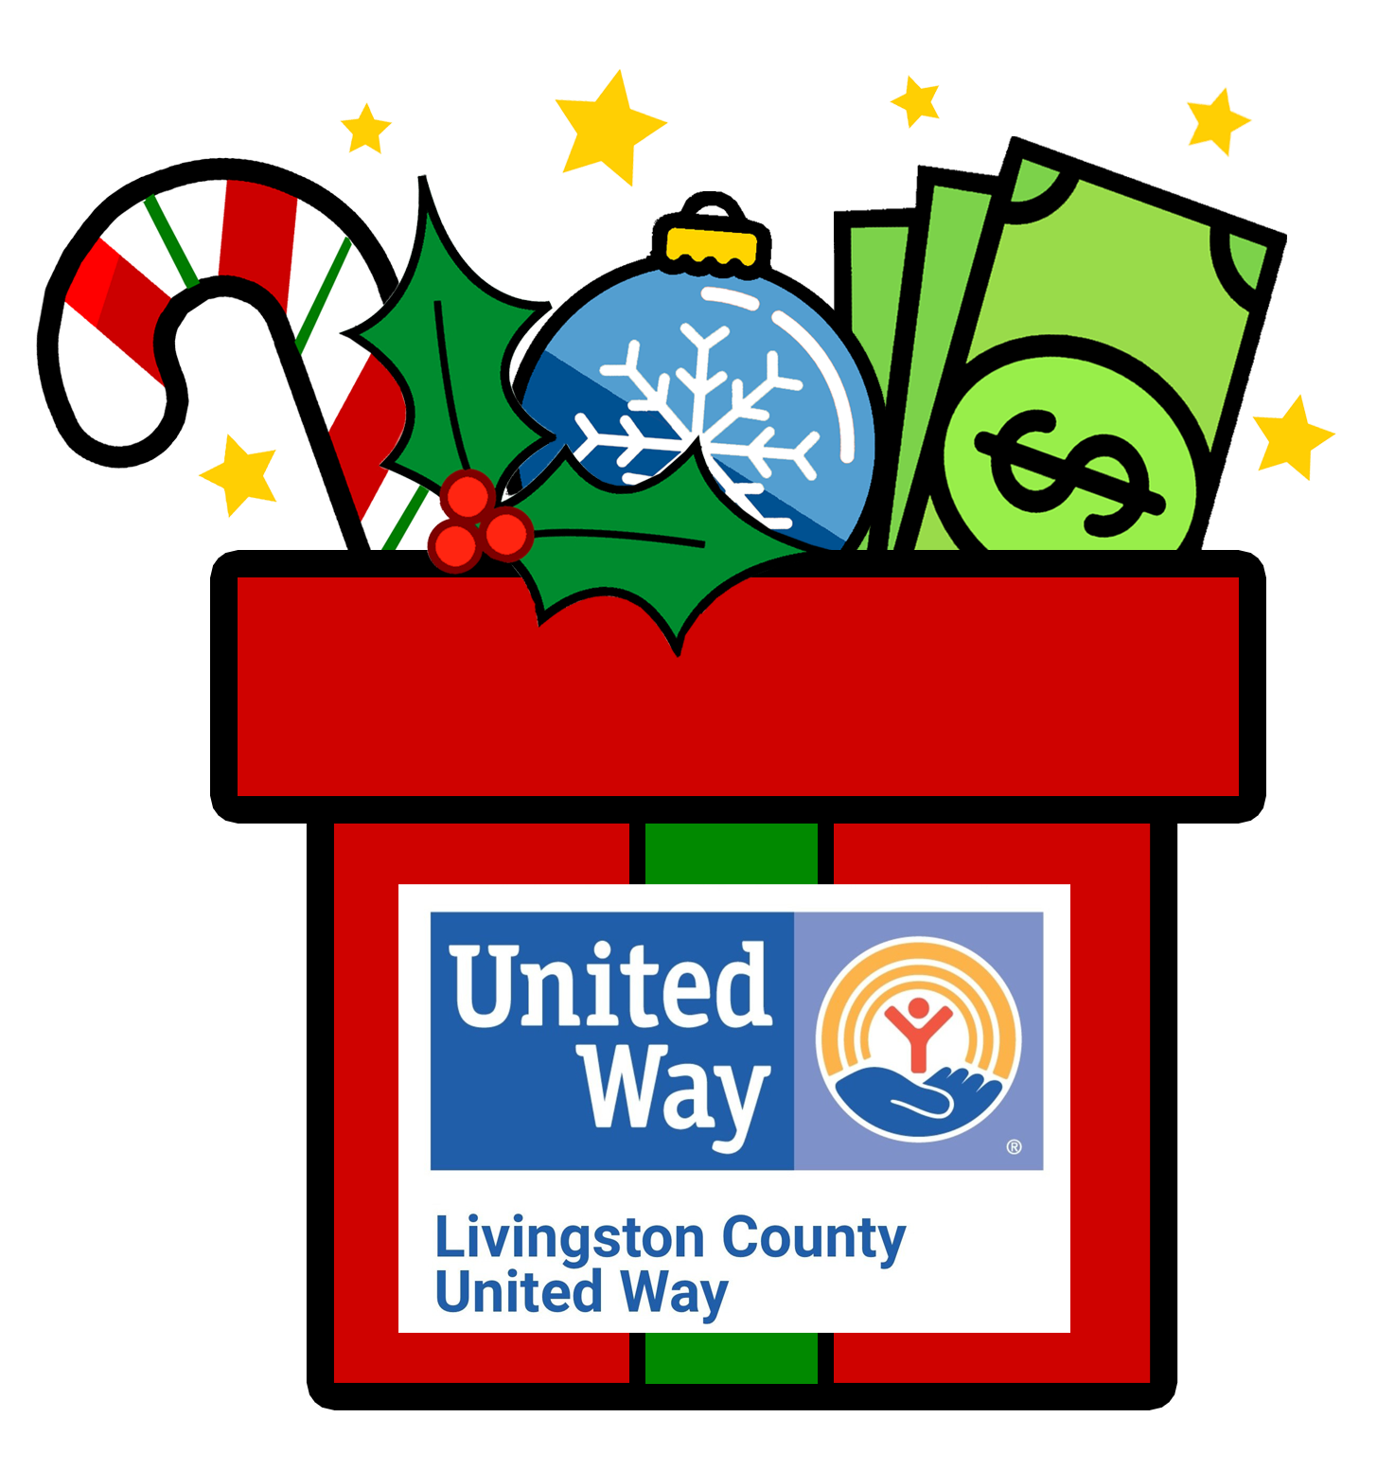

FOR IMMEDIATE RELEASE

Date: Wednesday, December 7, 2022

From: Anne Rennie, Executive Director

Re: 15th Annual Matching Money Monday is a great success!

Over the last year, we have watched our neighbors tackle gas prices and inflation challenges as they work to keep their homes warm, lights on and food on the table. This month, we all look forward to gathering together and celebrating the holidays with friends and families. That was certainly how it felt at Livingston County United Way’s Matching Money Monday held on December 5th. It was an event that reminded us why we do the work we do, and why we love this community!

This year we were able to invite people into our offices to enjoy some coffee, hot cocoa and cookies. What was amazing is the number of people who stayed and chatted with United Way staff and Board members or even just sat for a moment to nibble on a cookie. It was clear we all needed a moment to socialize and connect to each other.

A record number of sponsors came forward to provide the match for the event. Thirty-nine sponsors provided $125,800 to match all of the donations that came in on Monday. A remarkable 440 people came to our offices or logged in from home to donate $140,451, to help sustain the programs and services United Way supports. This results in a total of $266,251. A little shy of our $300,000 goal this year. These totals are pending final audit process.

This year we had some incredible community support in getting the word out. Twenty two local businesses put Matching Money Monday on their business Marquee. Another Thirty three businesses allowed us to put out yard signs at their business for the week before the event. We are go grateful for their support!

This event was more important than ever as all donations raised from Matching Money Monday will go directly to help local working families struggling to stay healthy, put food on their tables, keeping their lights & heat on, and a roof over their heads!

Thank you to everyone who made this day possible. Your generosity and commitment to making a difference in our community made us humbled and proud. If you have any questions or still want to donate, just contact Anne Rennie at arennie@lcunitedway.org or call 810-494-3000.

We also would like to thank the many long term donors and partners who stopped by to wish Mary Nye well in her retirement after 34 years!

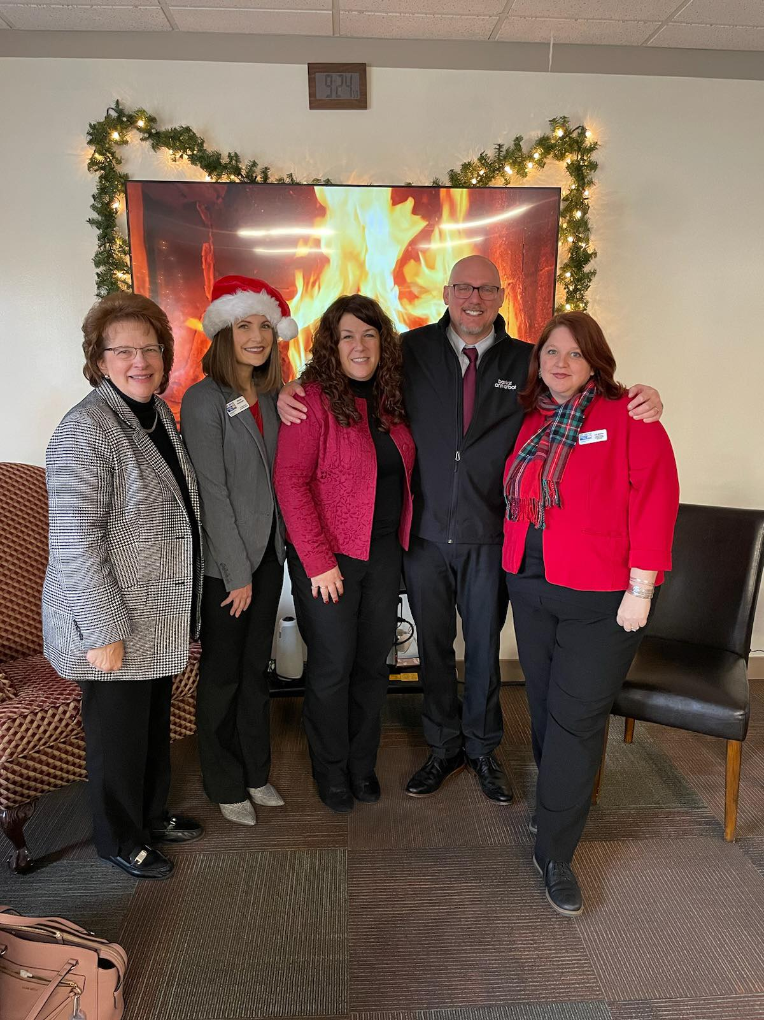
orr 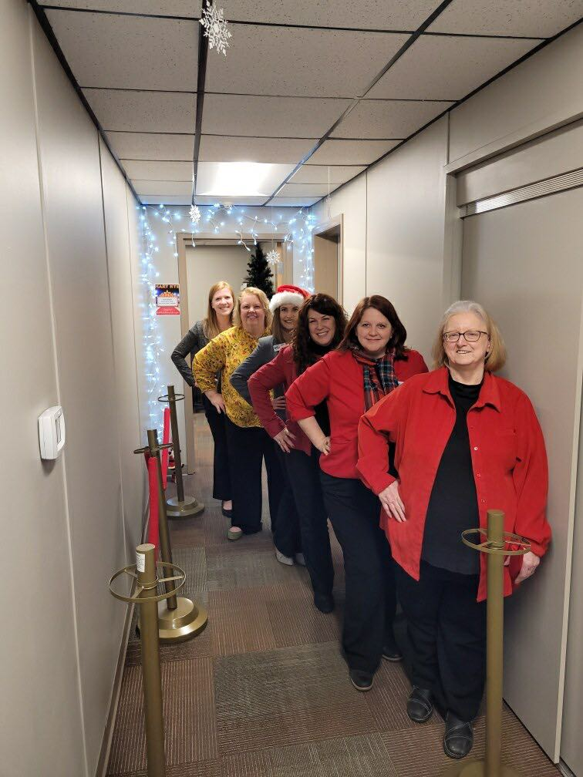Road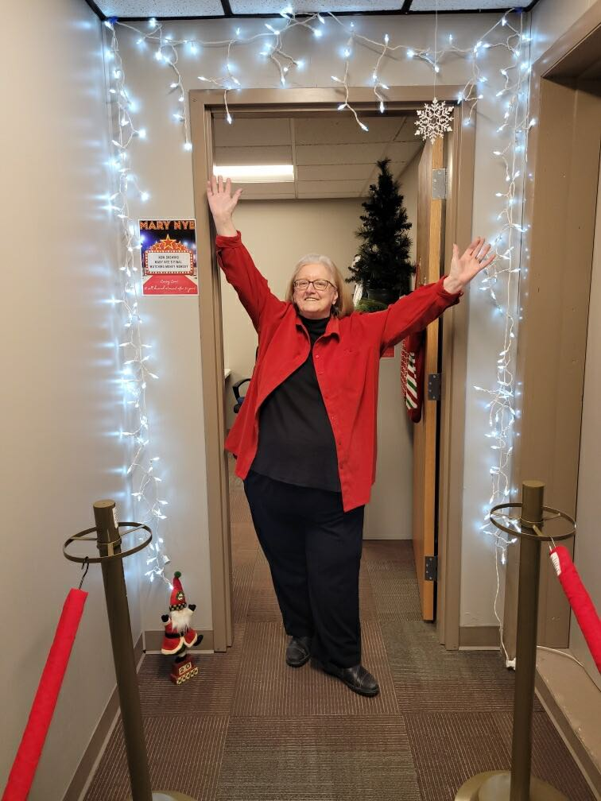, Brighton, Michigan 48116 · 810-494-3000 · F
# # #3004 · lcuw@lcu
2980 Dorr Road, Brighton, Michigan 48116 · 810-494-3000 · Fax 810-494-3004 · lcuw@lcunitedway.org

2980 Dorr Road, Brighton, Michigan 48116 · 810-494-3000 · Fax 810-494-3004 · lcuw@lcunitedway.org
2980 Dorr Road, Brighton, Michigan 48116 · 810-494-3000 · Fax 810-494-3004 · lcuw@lcunitedway.org
2980 Dorr Road, Brighton, Michigan 48116 · 810-494-3000 · Fax 810-494-3004 · lcuw@lcunitedway.org
2980 Dorr Road, Brighton, Michigan 48116 · 810-494-3000 · Fax 810-494-3004 · lcuw@lcunitedway.org

