For Immediate Release Contact: Samantha Jorgens
(810) 844-0240
sjorgens@vinadental.org

VINA Receives Generous Donation from Real Estate One of Brighton
VINA Community Dental Center received a generous donation from Real Estate One as a part of their Giving Tuesday fundraiser. On Tuesday, December 27, Hollie Kotwicki presented a check for $1,434.66 to VINA’s Executive Director, Samantha Jorgens to support VINA and the low-cost dental services provided to underserved adults in Livingston County.
Real Estate One of Brighton, Michigan received donations from employees and other fundraisers on Giving Tuesday. The Real Estate One Charitable Foundation matched all donations received that day. The Real Estate One Charitable Foundation was established in the late 1990's to provide an opportunity for the owners, the Elsea Family, corporate staff, and sales associates to give back to the communities where they work and live.
Real Estate One’s Giving Tuesday contribution will allow VINA to continue to spread smiles throughout the community by providing affordable, quality dental care to qualifying Livingston County residents. Patients at VINA only pay $25 for dental appointments and $10 for cleanings.
“It’s amazing to see businesses like Real Estate One step up and support local charities. The Livingston County community is constantly helping each other and their neighbors in need. We are incredibly grateful to the entire Real Estate One team and everyone who participated in their fundraisers for VINA,” said Jorgens.
For more information about VINA Community Dental Center or to find out how you can get involved, visit www.vinadental.org or call (810) 844-0240.
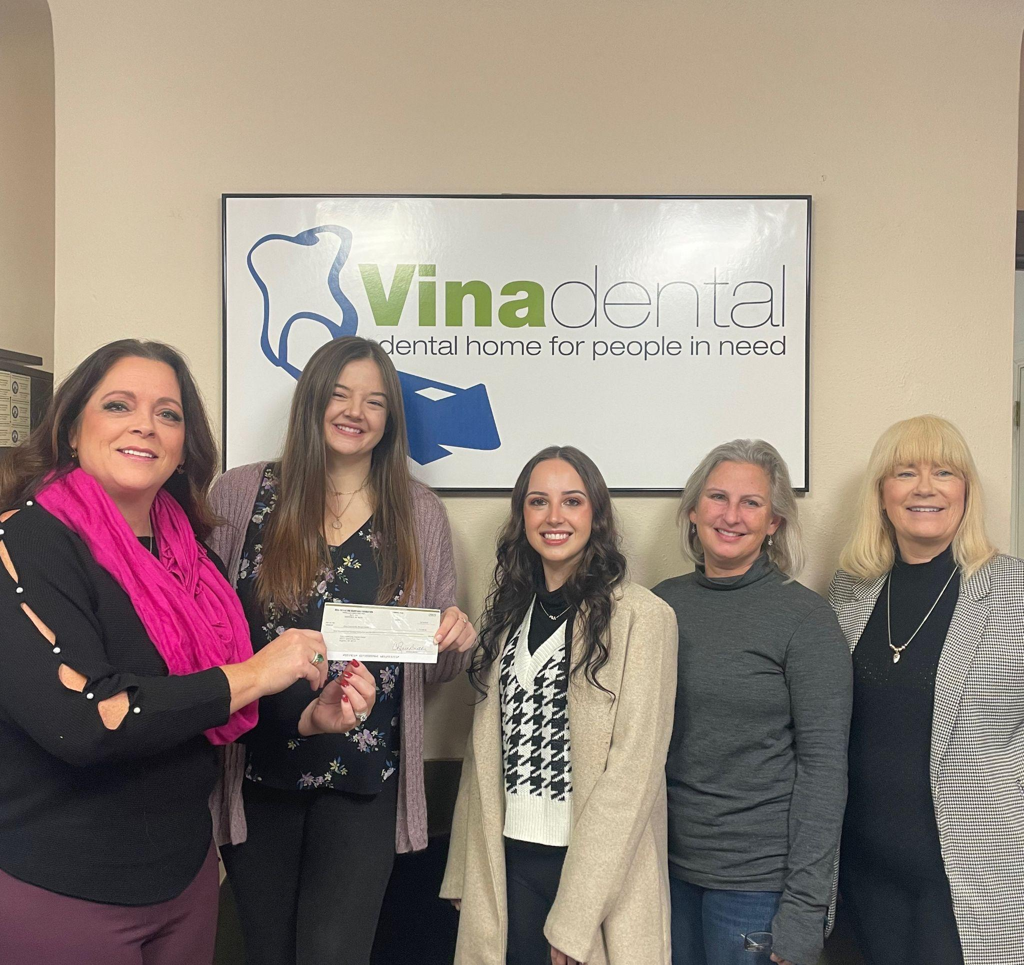
-##-

Pictured left to right: Hollie Kotwicki, Samantha Jorgens, Tori Tijan, Dr. Colleen Concepcion, Cathy Courtney

