Nominations Sought for 2023 Brighton Area Women’s History Roll of Honor

In recognition of the achievements and contributions by women of the greater Brighton area, nominations are being accepted through January 31, 2023, of potential candidates for induction into the Brighton Area Women’s History Roll of Honor.

Nominations are sought of qualified candidates that have achieved prominence or significantly contributed to the Brighton community while having lived, worked or been affiliated with the area for an extended period of time. Honorees have demonstrated distinctive accomplishments in the candidate’s chosen field of endeavor, professional or otherwise that are of an enduring nature to the social, cultural, economic, or political well-being of the community, state or nation. These honorees have given service or made commitments which have significantly advanced the status of women in society and exhibit qualities of character and personal ideals which serve as a positive influence on youth and as a model for other women.

Established in 2003 to inform, enlighten and inspire the accomplishments of area women, the Brighton Area Women’s History Roll of Honor has grown to include 113 women, and 8 Athletic Championship Honorees. Nominations will be accepted from individuals or from representatives of organizations and groups through January 31, 2023. Beginning January 5th, nomination forms may be obtained at the following locations: Brighton District Library at 100 Library Drive, Greater Brighton Area Chamber of Commerce Building at 218 East Grand River, or Brighton Area Schools B.E.C.C. Building at the corner of East Main and Church Streets. An online form is available at http://Brightonlibrary.info/roll_of_honor. Nominations must be received by January 31, 2023, to qualify for induction consideration this year.

The 2023 honorees will be honored during a recognition ceremony in August and announced during National Women’s History Month at the Joyce A. Powers Memorial Lecture on March 8. Recently retired and nationally celebrated University of Michigan softball coach Carol Hutchins will be the March 8 guest speaker to celebrate the 50-year anniversary of Title IX and its past and future effect on equal treatment for women.

Any questions concerning the nomination process may be directed to Brighton Area Women’s History Roll of Honor, c/o Brighton District Library, 100 Library Drive, Brighton, MI 48116, email at BrightonWomensHistory@gmail.com, or via telephone at 810-227-0656.

Brighton Area Women’s History
Roll of Honor

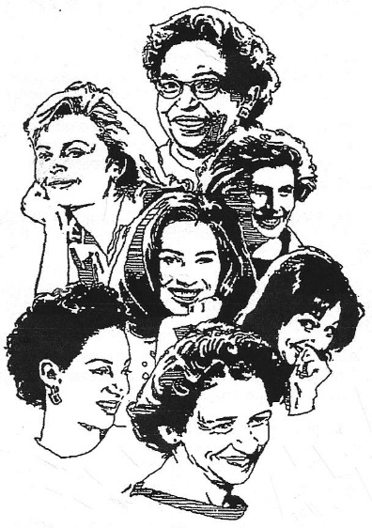
Our History Is Our Strength

2023 Nominations Due 1/31/2023
Celebrating the accomplishments of women that significantly enhanced the Brighton community, state, or nation, while affiliated with the area for an extended time period.

Forms available at:
- Brighton District Library, 100 Library Drive
- Greater Brighton Area Chamber of Commerce, 218 East Grand River
- Brighton Area Schools B.E.C.C. Bldg, corner of E. Main & Church
- http://Brightonlibrary.info/roll_of_honor.

Questions? Contact BrightonWomensHistory@gmail.com or 810-227-0656

Nominations Sought for 2022 Brighton Area Women’s History Roll of Honor

Nominations are being accepted through January 31, 2022, for potential candidates to be included into the Brighton Area Women’s History Roll of Honor.

Qualified candidates would have achieved prominence or significantly contributed to the Brighton community while having lived, worked or been affiliated with the area for an extended period of time. Honorees have demonstrated distinctive accomplishments in the candidate’s chosen field of endeavor, professional or otherwise that are of an enduring nature to the social, cultural, economic, or political well-being of the community, state or nation. These honorees have given service or made commitments which have significantly advanced the status of women in society and exhibit qualities of character and personal ideals which serve as a positive influence on youth and as a model for other women.

Established in 2003 to inform, enlighten and inspire the accomplishments of area women, the Brighton Area Women’s History Roll of Honor has grown to include 108 women, and 8 Athletic Championship Honorees. This distinguished group includes eleven members of the military, two of the first women to vote in Michigan, and 38 Brighton High School graduates.

Nomination forms may be obtained at:
Brighton District Library at 100 Library Drive,
Greater Brighton Area Chamber of Commerce Building at 218 East Grand River,
Brighton Area Schools B.E.C.C. Building at the corner of East Main and Church Streets, or
online at http://Brightonlibrary.info/roll_of_honor.

The 2022 honorees will be announced in March during National Women’s History Month and honored special ceremony to be scheduled once COVID19 restrictions are lifted.

Any questions concerning the nomination process may be directed to Brighton Area Women’s History Roll of Honor, c/o Brighton District Library, 100 Library Drive, Brighton, MI 48116, email at BrightonWomensHistory@gmail.com, or via telephone at 810-227-0656.

