2023 Nominees of the Brighton Area Women’s History
Roll of Honor

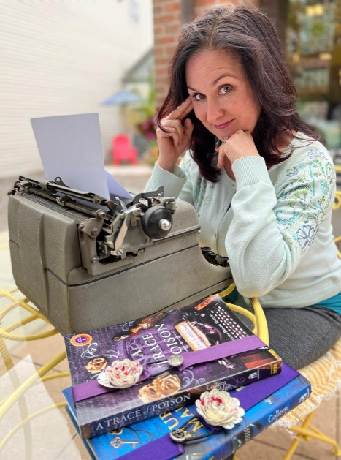

Colleen Gleason has been a Brighton resident since 1996 and is an award-winning, USA TODAY, and New York Times best-selling author. She has written more than 40 full-length novels that have been published in a wide range of genres. Pen names she’s used include Colleen Gleason, Colleen Cambridge, and C.M. Gleason. She has written everything from teen novels to action-adventure/thrillers to vampire books to mysteries, and currently is focusing on a series featuring Agatha Christie’s housekeeper as an amateur sleuth, and another series featuring a (fictional) former Rosie the Riveter who worked at Willow Run Bomber Plant and has moved to postwar Paris, where she meets and solves mysteries with Julia Child. Colleen began writing in primary school and wrote eight complete novels during her early career and raising a family before selling the first book of her The Gardella Vampire Chronicles series to a division of Penguin Books, which was published in January 2007. Besides Penguin, Colleen has written for HarperCollins Publishers, Harlequin/MIRA, and Chronicle Books. She currently writes for Kensington Books. Before becoming a full-time writer, Colleen worked in sales, marketing, and management for a variety of companies, including Care Choices/Trinity Health, as well as two start-up companies. She started her own business in the insurance field which went by the wayside when she sold the rights to her first two novels in 2005. She has been writing full-time ever since. Colleen has a BA English and an MBA from the University of Michigan. Colleen has been a huge supporter of 2Dandelions Bookshop since it began in 2019, collaborating on multiple book launches and hosting a monthly book club featuring diverse authors in a range of genres. She speaks regularly at book clubs, schools, libraries, and conventions, and does workshops for writers whenever possible. Colleen and her husband are very active in their church in Brighton and have organized fundraising talent/variety shows for Cystic Fibrosis research as well as for the Ukraine.

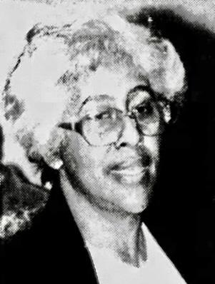

Thelma Lett (1929-2008) was the twenty-year Membership Director of the Livingston Diversity Council who stood and spoke against a hate group in 1994 stating that Livingston County was her home and that her family had a right to live with dignity and without harassment. Thelma’s refusal to leave Livingston County because of racial intimidation was widely applauded and recognized by Congresswoman Elissa Slotkin in 2022 for Black History Month. Before moving to Livingston County in 1976, Thelma began her career selling shoes door-to-door during the depression. Along with her aunt and sister, 17-year-old Thelma expanded the business into Hawkins Apparel and opened two Detroit locations—one on Warren Avenue and one in Dexter/Davison. The 1967 Detroit Riots burned those businesses. Earning a bachelor’s degree in accounting from the Detroit Institute of Technology, Thelma worked at Detroit Edison in accounting almost 18 years before retiring. Thelma joined the First United Methodist Church of Brighton and car-pooled nine years to her Detroit-based job with four male Detroit Edison employees. When Thelma became the only African-American member of Brighton Church of the Nazarene, she inspired others and was extremely active, enjoying prayer groups and the youth-oriented contemporary services. Her organization and drive with the Community Coalition translated into coordinating special activities throughout Livingston County during their October, 1994, support of community diversity. Thelma was recognized at the 20-year celebration of the Diversity Council and reminded the audience to put their love of people and God “into action.” The Thelma Lett Library can be found within the Detroit Impact Youth Center as a tribute to the many young people she taught to read and write.

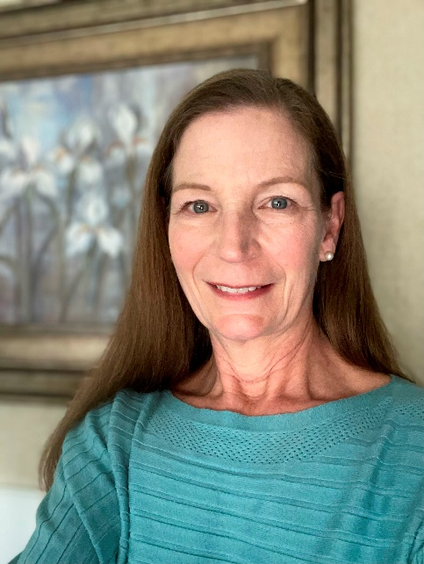

LuAnn Loy moved to Brighton in 1985 and is an advocate for students of all ages and abilities. In 1995, LuAnn served on the Advisory Committee for Special Needs of the Imagination Station Planning Committee. In 1996, LuAnn was a board member for Livingston Technical Academy, aka Kensington Woods Schools. Since 1996, she has been a member of the Wayne State University Community Advisory Committee for the Developmental Disabilities Institute, focusing on research, education and training programs. From 1992-1993, LuAnn served on the Michigan State Board of Education, Identifying Barriers to Inclusive Education Recommendations Committee. From 2004-2005, LuAnn was a member of the State of Michigan’s Team Task Force for Alliance for Full Participation to identify critical issues affecting people with disabilities. Active in the Livingston Educational Service Agency’s (LESA) Board of Education since 2005, LuAnn has been president since 2014. LuAnn and daughter Abby appeared before Congress petitioning for the Prenatal and Postnatal Diagnosed Conditions Awareness Act. Since 2001, LuAnn is a third generation active member of the Philanthropic Educational Organization (P.E.O.) Sisterhood, Brighton Chapter EF. LuAnn is has been a member of the Brighton Rotary Club since 2013, and is a US Army Veteran, having served in the 295th Aviation Company from 1975-1977. LuAnn holds a Bachelors of Arts in Accounting from Michigan State University and is the inventor and patent holder of ShoeSling®.

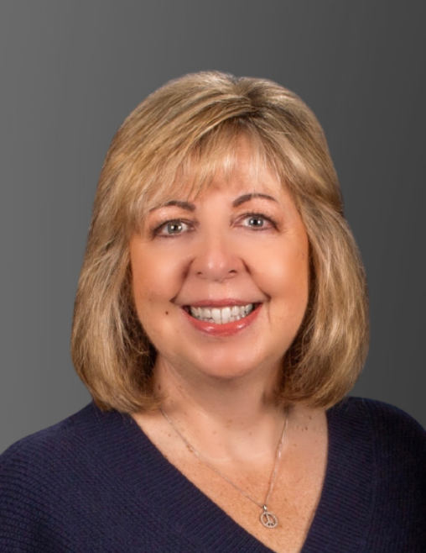

Anne Richardson has lived in Brighton since 1992, and formed a parent support group in 1996 for parents of children with disabilities in Livingston County. She was a member of the Lindbom Elementary PTO, and served as Chair and member to the Livingston Educational Service Agency (LESA) Parent Advisory Committee. Anne worked for the Washtenaw Association for Community Advocacy by assisting in the coordination of Partners in Policymaking to educate adults with disabilities and parents about special education, public support systems, and the policymakng process. In 2002-2015 Anne worked as a family advocate at The Arc Livingston, serving 250 community members yearly, specifically supporting individuals with disabilities and their families through information, education, and one-on-one support to access services in Livingston County. Anne led The Arc Livingston as Executive Director 2015-2021, bringing financial stabiity, expanding programs, and raising awareness for equity and inclusion of those with disabilities. Even in retirement, Anne continues to be an active, supportive member. She has served on the Board of the Livingston Diversity Council since 2017. A former member of the Livingston County Human Services Collaborative Body (HSCB), Anne has served on the HSCB Executive Committee, the Livingston Hunger Council, the Livingston Council for Youth, and is a founding and current member of the Abilities Alliance.

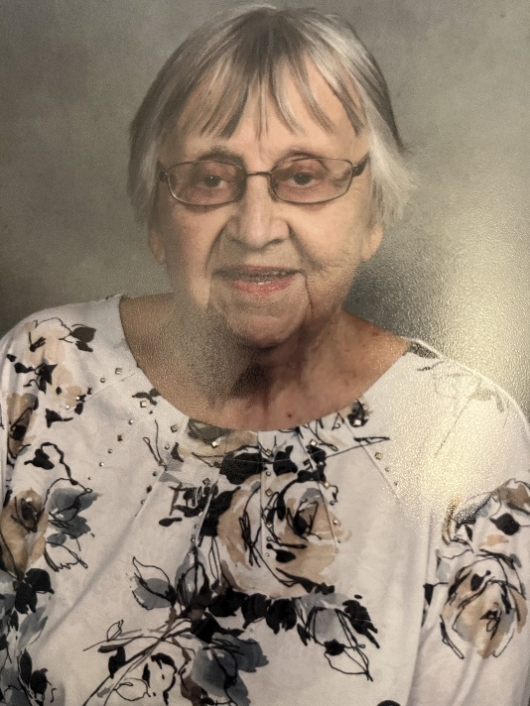

Jane Jarvis Tomlinson was born in Mellus Hospital, graduated from Brighton High School in 1951, and her family ties to Brighton originated in the 1800s. Her family-owned business, Jarvis Menswear, at 306 Main Street operated for many years with Jane as seamstress and sales clerk. Since well-tailored menswear was the major product of the business, Jane’s role was extremely important. A member of the First United Methodist Church since 1944, Jane has served on the memorial committee and as a Sunshine Lady for well over ten years, sending hundreds of handwritten cards to church members sharing sympathy, get well thoughts, or Easter wishes and devoting most mornings to her responsibilities. When the church operated the Red Balloon Tea Room, located on Brighton Lake Road and Grand River, Jane volunteered to serve luncheons for over ten years. Jane also helped coordinate the annual Salad Luncheons for church members, a very popular and well-organized event. Jane is an active member of the Brighton Area Historical Society and enjoys sharing her knowledge of Brighton History. She is also a member of the Brighton Area Schools Alumni Association and the Pleasant Valley Social Club.

Outstanding Historical Accomplishments by Young Women

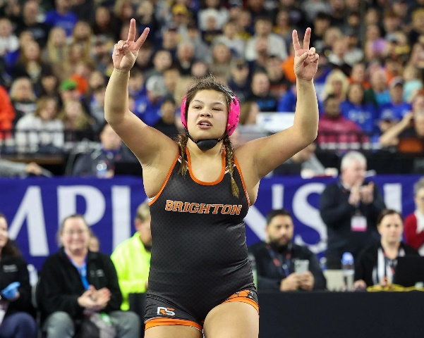

Sabrina Ann Nauss became the first female to win a Michigan High School Athletic Association (MHSAA) wrestling championship on March 5, 2022, at Ford Field. Sabrina topped the 16-girl bracket to earn her title undefeated. During her youth wrestling career, Sabrina won multiple state championships in the boys division, is number 4 nationally out of all women wrestlers in all weight divisions, and is currently ranked number 1 nationally for her particular weight class (and has been since 2021).

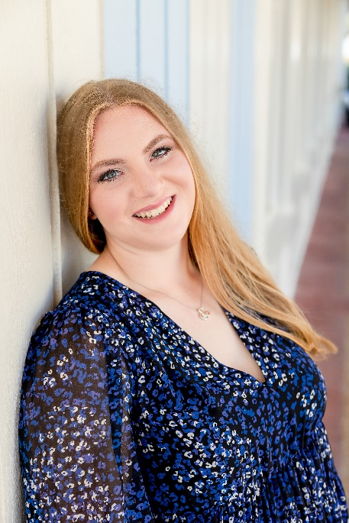

Genevieve Urbain is a 2022 graduate of Brighton High School. In 2012 as a second-grade student, Genna became acquainted with the story of Willis Ward (1912-1983), an African-American student, athlete, civil rights activist and judge, and felt that Willis Ward’s accomplishments and challenges resulting from Jim Crow prejudices should be recognized at The University of Michigan. Genna spoke to the UofM Board of Regents and the Michigan State Senate. Her efforts resulted in a UofM Football Game Day honor for Willis Ward at Michigan Stadium, a 2015 opening of the Willis Ward Lounge in the Michigan Union at UofM, and the designation of Willis Ward Day on October 19, 2012, by the Michigan State Senate.

