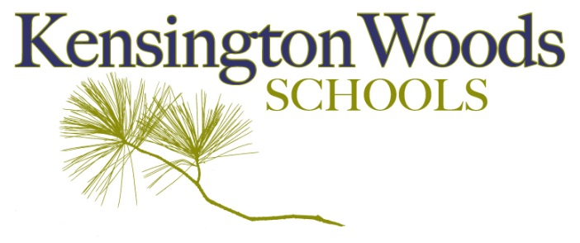
Contacts:
Jessie MacGonigal Pratt - Principal (517-545-0828)

FOR IMMEDIATE RELEASE

KENSINGTON WOODS LAUNCHES NEW EARLY COLLEGE PROGRAM

LAKELAND, MICHIGAN — March 29, 2023 — Kensington Woods Schools is pleased to announce the opening of their new Early College program in the fall of 2023.

Kensington Woods Schools Early College Program (also known as an Early Middle College, or EMC for short) allows students to earn an associate degree, up to 60 transferable college credits, a professional certification or participate in a registered apprenticeship in addition to their high school diploma over a 5 year high school course of study.

Kensington Woods Schools will cover the cost of tuition, books and fees for their Early College students while enrolled in the program.

The program has been in the planning stages for a few years but was recently green-lighted by the Kensington Woods Board of Education and then the Michigan Department of Education. The school saw the need for a supported transition from high school to college for its students and the Early College format met that need.

“Students thrive in the smaller, personal environment at Kensington Woods,” said Principal Jessie MacGonigal Pratt. “It makes sense to help them transition to college and other post-secondary experiences with a similar, supported experience.”

Partnering with Washtenaw Community College as their post-secondary partner, students enrolled in the Kensington Woods Early College will be able to enroll in a variety of programs including College Foundation, General Studies, Computer Science, Human Services, Welding and Fabrication, Automotive Services, Robotics, Graphic Design, Audio Production & Engineering, Fine Arts and 3D Animation. The programs were selected to focus on the different needs and strengths of Kensington Woods students while still offering flexibility of options.

Students can enroll in the Early College program starting their 10th grade year. The Early College program will include preparatory classes for interested 9th grade students and seminar classes to support enrolled students navigate the post-secondary environment and build skills for success. This is in addition to the regular Kensington Woods curriculum that all students will participate in, which includes a large focus on academic and soft skills, character building and subject-area integration where students investigate content through the lens of two different subject areas. Students enrolled in the Early College program still have access to all programs at Kensington Woods, including athletics, extracurricular, art, music and academic support, even through the fifth year as well as programs and supports at Washtenaw Community College.

“We are really excited to offer another option for our students to support them becoming successful after high school and reaching their full potential,” said MacGonigal Pratt.

According to data from the Michigan Department of Education, nationally, EMC students graduate from high school at a higher rate than other students and earn an average of 23 college credits upon graduating from high school. 54% of Michigan Class of 2020 EMC students earned more than 60 credits.

Kensington Woods Early College program will be one of 176 in the state and the first in the county based within a high school.

-end-

For further information about Kensington Woods Schools, call 517.545.0828 or via email at info@kwoods.org. Kensington Woods Schools is located at 9501 Pettys Road, Lakeland, MI 48143.
Kensington Woods Schools is a 6th – 12th grade college preparatory, tuition-free, state-funded school.

