FOR IMMEDIATE RELEASE
Contact:
Amy Johnston
Community Collaborative Planner
810.772.4827 | ajohnston@cmhliv.org April 24, 2023
Understanding the Risks of Marijuana: A Focus on Safety
The Substance Use Disorder Treatment, Prevention and Recovery (SUD) Workgroup of the Human Service Collaborative Body is a partnership of local substance use agencies who work together to create a continuum of services and supports for people experiencing addiction and recovery.

Marijuana – Since marijuana use has been legalized in some states, accidental marijuana poisonings in children have increased, sometimes requiring visits to the emergency room or hospitalization. The number of incidents in which children younger than 6 accidentally ate edible cannabis products increased 1,375% from 2017 to 2021 according to the January 3, 2023 edition of the Washington Post. As marijuana becomes more accessible, it is important to understand the risks associated with marijuana use and keep our focus on safety.

Today’s marijuana has 217% more of the psychoactive ingredient THC than it did in 1995 and can come in more concentrated forms, known as wax, dabs, and oils. Additionally, marijuana now comes in forms that are appealing to youth, such as candies or cookies. Children and pets can become very sick after mistakenly consuming marijuana products, particularly edibles, that look like regular food. They may have problems walking or sitting up or may have a hard time breathing.

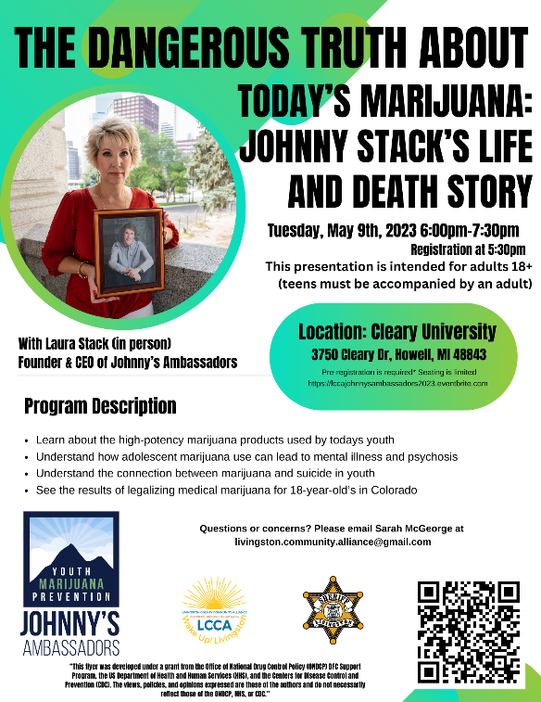
Marijuana use also directly affects brain function. Marijuana use quadruples the risk of developing psychosis, and doubles the risk of developing depression or bipolar disorder. Use among youth may affect how the brain builds connections and lead to long-lasting or even permanent effects.

You can keep kids and pets safe by locking up marijuana! Local agencies are providing lock boxes free of charge to encourage safe storage of marijuana products. Making marijuana less accessible will prolong the age of first use, which will decrease the likelihood of becoming addicted to the substance. For more information about preventing accidental exposure, please visit talksooner.org/marijuana.

To get involved in youth prevention activities, check out: Livingston County Community Alliance or plan to attend The Dangerous Truth About Today’s Marijuana: Johnny Stack’s Life and Death on May 9th at 6 pm at Cleary University in Howell. Registration is required.

To increase safety messaging within the community, the Livingston County Health Department (LCHD) will be using funding received from Michigan Licensing and Regulation Affairs (LARA) for marijuana education and outreach. In collaboration with the Human Services Collaborative Body (HSCB) and the SUD Workgroup, LCHD will determine priority topics and highlight risks, rules, and legal implications related to marijuana. These messages will be shared through advertisements, billboards, fact sheets, and more.

Learn more about the issues impacting Livingston County: Fact you should know about marijuana and how it affects youth, Underage Alcohol Use in Livingston County Fact Sheet, Opioids in Livingston County Fact Sheet, Electronic Cigarettes Fact Sheet, and Recovery in Livingston County Fact Sheet.
In case of accidental use or ingestion of marijuana products, call the Poison Control Center immediately at (800) 222-1222.

To obtain more information, contact Amy Johnston at 810.772.4827 or at ajohnston@cmhliv.org.
###

