312 S. Michigan Ave. Howell, MI 48843
517-546-6329 livingstoncremation.com
Anna Warnstrom, Manager

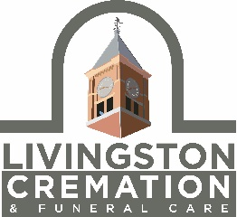
PRESS RELEASE
Affordable Cremation Service comes to Livingston County
Livingston Cremation and Funeral Care, a Michigan Licensed Funeral Establishment, has opened to provide local, attentive and affordable cremation service to Livingston County.
When interviewing local care providers, hospice workers, Clergy and Elder Law Attorneys, Todd Borek and Karl Jennings, owners of Borek Jennings Funeral Homes, discovered that more than 250 families each year had to leave our community to find affordable Cremation Services elsewhere. “We also learned of the deep frustration many families experienced when using these services.” said Todd Borek.
Out-of-county services advertise locally and online, and then transfer your deceased loved one to large warehousing facilities in Oakland, Washtenaw, Wayne, Genessee and Ingham Counties. Often, the convenience of online or over-the-phone arrangements is replaced by the frustration of having to wait weeks or longer for their loved one’s urn to be returned via the postal service. Additionally, families recounted having to wait weeks for legal documents that delayed accessing or closing accounts and settling their loved one's estate.
“We want to provide more attentive service and be responsive to the concerns and needs of these families,” said Karl Jennings.
Therefore, eight months after they opened their new state-of-the-art funeral home at 1700 Highland in Howell, they decided to repurpose their downtown Howell location (312 S. Michigan in Howell) to provide the local, attentive and accountable service for families seeking affordable cremation services.
The name, Livingston Cremation & Funeral Care, reflects both our home and our desire to have neighbor serving neighbor. For more information call 517-546-6329 or go to www.livingstoncremation.com.

