NATIONAL NIGHT OUT
Join the Northfield Township
Police and Fire Departments
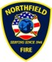
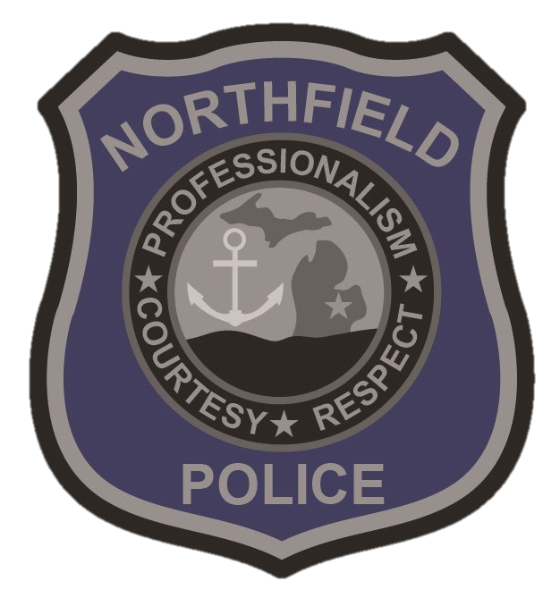
& Partnering Agencies
August 1, 2023
5 PM -8 PM
8877 Main Street-Old Middle School
Whitmore Lake MI, 48189
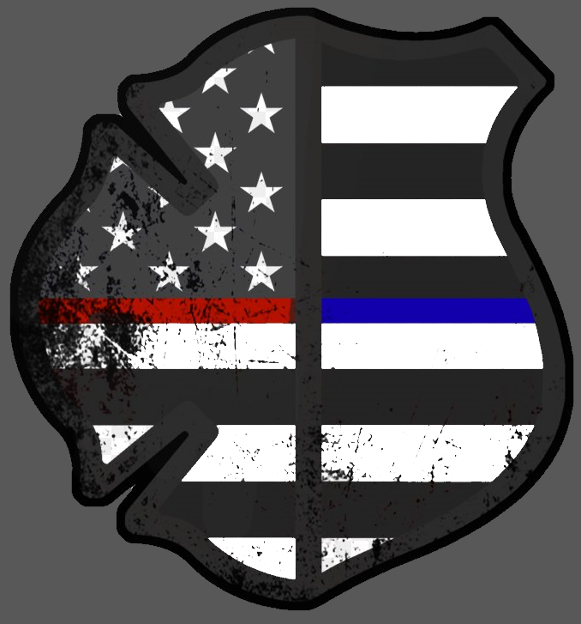
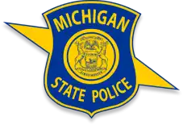

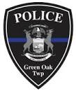

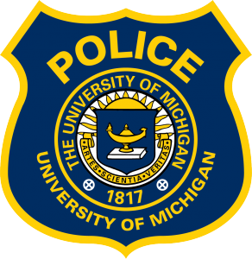
National Night Out is an annual event throughout the US and Canada. This will be a time for the public to interact with local heroes, to learn more about them and their jobs. Come out for a fun-filled engaging time with a petting zoo, bounce house, concessions, and informational pamphlets provided free to all.
Call 734-449-9911 for more information.

