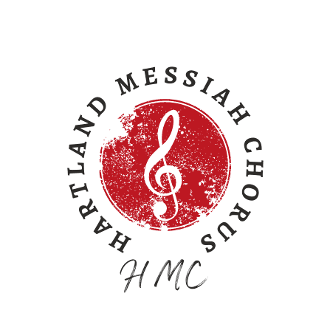

For immediate release.

Contact: Carlton Davis, Business Mgr. Phone: (810)844-3508
Hartland Messiah Chorus Email: Messiah@earthlink.net
1333 Rolling Hills Drive Website: www.HartlandMessiah.com
Howell, MI 48843 FaceBook: HartlandMessiahChorus

90th Annual Performance of Handel’s Messiah at historic Hartland Music Hall

The Hartland Messiah Chorus, directed by Kelli Falls, performs the entire Handel’s Messiah choral oratorio accompanied by Richard Helderop on the vintage Kilgen pipe organ. This landmark 90th annual performance will occur on December 9, 2023 at 4pm in the circa 1858 Music Hall in Hartland, Michigan.

Hartland benefactor, J. Robert Crouse, started our Messiah tradition in the 1930s. It continues today as a living memorial to Mr. Crouse and his legacy.

Tickets are available for $15 on EventBrite.com (Link: bit.ly/HartlandMessiah2023) and at the door while they last.

Hartland Messiah Chorus is a 501c3 non-profit community chorus whose sole purpose is the annual presentation of Handel’s Messiah on the 2nd Saturday of each December at the historic Hartland Music Hall, 3619 Avon St., Hartland, MI 48353.
