

**Brighton Township is hosting a**

**Red Cross Blood Drive**

**Thursday, December 21, 2023**

**12:00 p.m. to 6:00 p.m.**

**Location:**

**Brighton Township Hall**

**4363 Buno Rd, Brighton MI 48114**

To schedule an appointment, follow the link below:

<https://www.redcrossblood.org/give.html/drive-results?zipSponsor=Brightontwp>

or log onto RedCrossBlood.org (sponsor code Brightontwp)

or call 1-800-RED CROSS (1-800-733-2767)

­­

Streamline your donation experience and save up to 15 minutes by visiting RedCrossBlood.org/RapidPass to complete your pre-donation reading and

health history questions on theday of your appointment

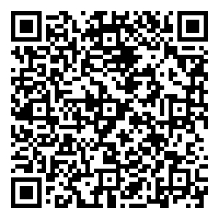

Scan to schedule

an appointment

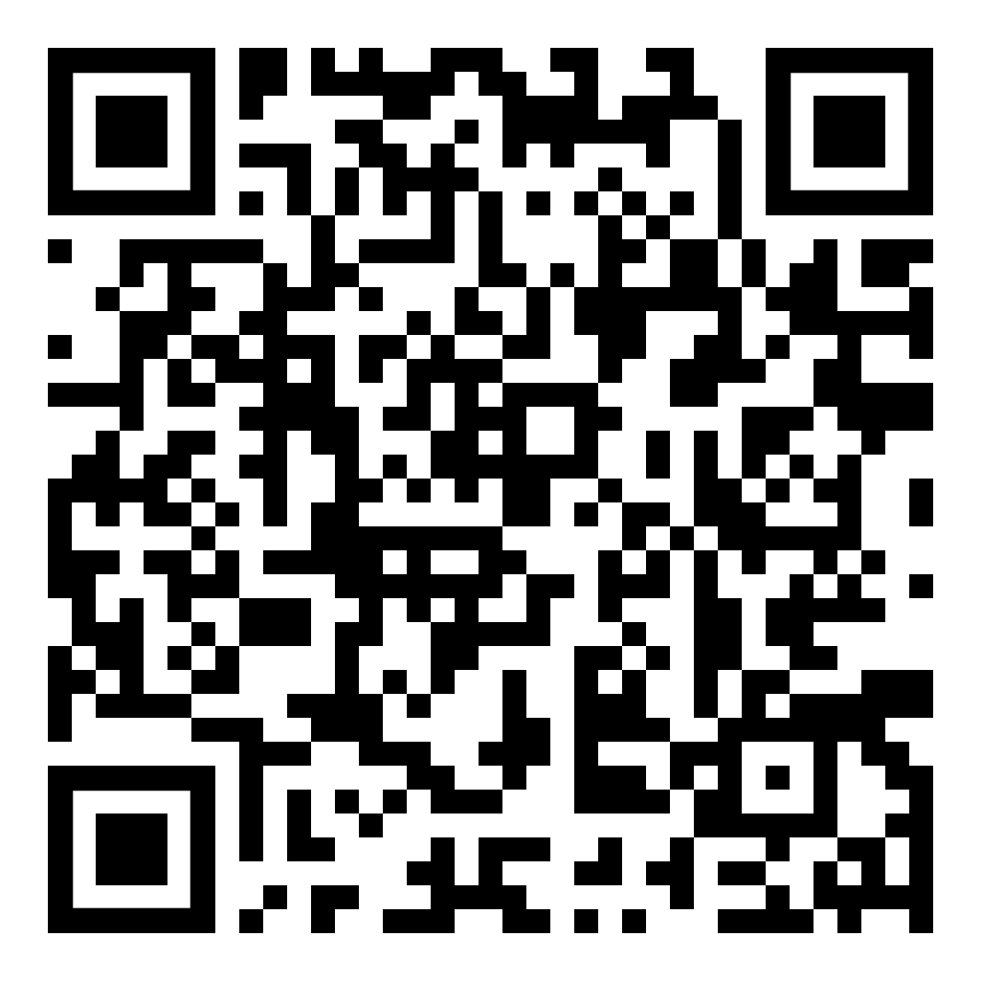

Scan to be directed to RapidPass®