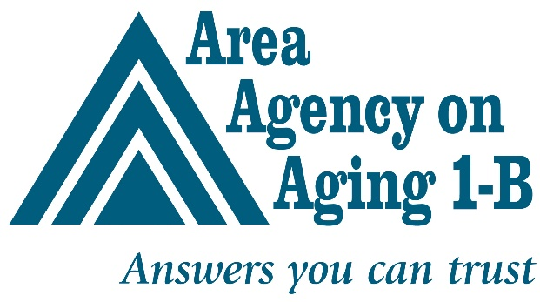

November 28, 2023

GRANT BOLSTERS ADVOCACY FOR RESIDENTS OF LONG-TERM CARE FACILITIES

Contact: Julie Edgar: 248-897-8182/jedgar@aaa1b.org

SOUTHFIELD -- A Healthy Aging grant will enable the Area Agency on Aging 1-B (AAA 1-B) to double the number of advocates who fight on behalf of nursing home residents and their families.

The Michigan Health Endowment Fund (MHEF) awarded $386,188 to the AAA 1-B, which houses the Long-Term Care Ombudsman (LTCO) program for the six counties in its service region. It will enable the agency to hire three additional long-term care ombudsmen, whose role it is to monitor complaints lodged by residents of licensed long-term care facilities, primarily nursing homes, and their families. Other licensed long-term care models include adult foster care homes and homes for the aged.

“We are thrilled that MHEF recognizes the need for additional ombudsman services in our region and was willing to support the program by providing immediate relief to increase access to these vital services,” says Katie Wendel, Director of Planning and Advocacy.

The three ombudsmen who staff the LTCO program at the AAAA 1-B are among just 20 throughout Michigan. The trio monitors 140 long-term care facilities in Livingston, Macomb, Monroe, Oakland, St. Clair and Washtenaw counties. Last year they fielded 1,100 complaints from families alone.
Ombudsmen also focus on quality of life for residents, such as call light response time, personal hygiene, treatment by staff, and other issues.

There are some 100,000 nursing home residents and residents of other licensed long-term facilities in Michigan. The average statewide ratio of ombudsman to long-term care facility resident is 1:5200. The grant will enable the AAA 1-B to reduce the number to 1 ombudsman to 2000 residents in a few areas within the six counties that it serves.

The MHEF awarded a total of $14.3 million to support 48 initiatives throughout Michigan that will support older adults and their caregivers, engage changemakers in health equity and access, leverage close community partnerships to drive wide-reaching efforts in community health, and more.

About MHEF

The Michigan Health Endowment Fund works to improve the health and wellness of Michigan residents and reduce the cost of healthcare, with a special focus on children and seniors. You can find more information about the Health Fund at mihealthfund.org.

About AAA 1-B

The Area Agency on Aging 1-B is a nonprofit that serves older adults and family caregivers in Livingston, Macomb, Monroe, Oakland, St. Clair and Washtenaw counties. We provide services, programs and resources that are designed to help seniors age safely and independently. Call us at 800-852-7795 to get connected.

