Consumers Energy’s Reliability Roadmap: Power Restored to Nearly 90% of Customers in Less Than 24 Hours in 2023
Electric Grid Upgrades Shorten Outages; More Work on the Way This Year
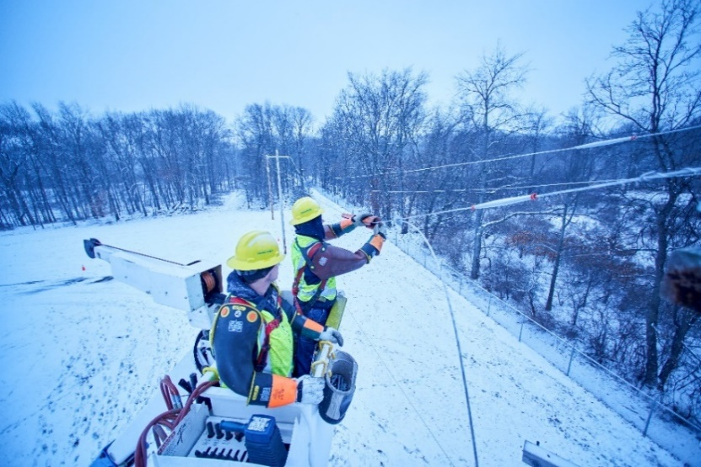
JACKSON, Mich., Feb. 6, 2024 – Consumers Energy announced today that nearly 9 in 10 customers who lost power in 2023 were restored in less than 24 hours -- the result of the company’s major upgrades to strengthen Michigan’s electric grid.

Michigan’s largest energy provider last year unveiled its Reliability Roadmap – a long-term commitment to improve reliability and restore all customers in less than 24 hours, even after severe storms.

Consumers Energy put that plan into action, reducing the length of the average customer outage last year during normal weather to 176 minutes, or under three hours – a 20-minute improvement over the average for the previous five years.

“We are trimming trees, using technology and burying more power lines to build a power grid that is reliable in all weather,” said Greg Salisbury, Consumers Energy’s vice president of electric distribution engineering. “We all saw the threat from severe weather, in the form of intense back-to-back storms just last month, where we restored power to most customers in less than 24 hours, which makes us even more determined to make outages as infrequent and as short as possible.”
“Michiganders are expecting us to provide energy even more dependably than ever, and our performance last year shows we’re able to follow through on our plan,” said Chris Laird, Consumers Energy’s vice president of electric operations. “We’re going to continue following our Reliability Roadmap to ensure the power stays on for homes and businesses that count on us.”

Consumers Energy operates close to 100,000 miles of electric lines and serves nearly 2 million homes and businesses. In the past year, Consumers Energy continued to innovate with new technology and upgrades to its electric system across the entire Lower Peninsula. That work included:
- Carrying out 150 major upgrades across Lower Peninsula communities.
- Clearing tree branches from over 7,000 miles of power lines, addressing the No. 1 cause of power outages in Michigan.
- Upgrading, rebuilding and expanding over 100 substations.
- Added smart technology including nearly 100 Automatic Transfer Reclosers (ATRs) that help limit the number and length of power outages.
- Strategically burying electric lines in areas that would receive the greatest benefit for less cost.
Consumers Energy expects to make even more investments in the electric grid this year, helped by a $100 million federal commitment to its Reliability Roadmap. The company will start spending those funds, focusing on upgrades to the grid in disadvantaged communities.
Consumers Energy is Michigan’s largest energy provider, providing natural gas and/or electricity to 6.7 million of the state’s 10 million residents in all 68 Lower Peninsula counties. Consumers Energy knows job No. 1 is to keep the lights on for customers. We are committed to delivering reliable, clean, and affordable energy to our customers 24/7.
###
For more information about Consumers Energy, go to ConsumersEnergy.com.
Check out Consumers Energy on Social Media

