****PRESS RELEASE****

DEALERSHIP BREAK-IN / STOLEN CARS
REPORT #24-000052

On March 10th at approximately 5:30am, the Pinckney Police were dispatched to a suspicious situation at the Pinckney Chrysler Dealership. As officers responded to the area, a car was stopped on Kirkland Ct by Pinckney PD. As soon as the officer activated the overhead patrol car lights, three new Dodge vehicles fled the area at a high rate of speed. The car that was stopped was a newer Chevrolet with one occupant.

With other Livingston County Law Enforcement partners responding to assist, a white Dodge Charger was stopped by Brighton PD. It was confirmed that this was one of the vehicles from the dealership. Another vehicle entering the area was stopped by the Michigan State Police. This vehicle was also involved and is still under investigation. The driver was taken into custody.

UPDATE

On 03-12-24 the Honorable Magistrate Sherwood of the 53rd District Court arraigned two subjects in relation to this case.
Desean Stanley, an 18yr old male from Detroit was charged with 12 felony counts related to this incident. His bond was set at $500,000 cash/surety.
Armarion Gaskin a 21yr old male from Detroit was charged with 1 felony count and his bond was set at $25,000 cash/surety.
A 17yr old male from Warren was also involved and we are currently seeking charges through the juvenile court system.
Both adult subjects will be given a future court date for a preliminary exam. This investigation is continuing with other suspects being sought by the Pinckney Police.

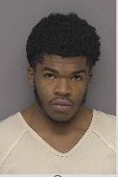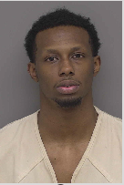
Desean Stanley Armarion Gaskin 17yr old Juvenile
***

