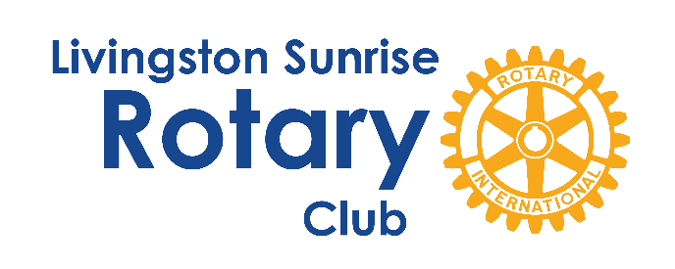

For Immediate Release Contact: Dianne McCormick
Monday, August 26, 2024 LivingstonSunriseRotary@gmail.com

Livingston Sunrise Rotary Club Celebrates 20th Anniversary

Howell, MI – The Livingston Sunrise Rotary Club (LSRC) is proud to announce its 20th anniversary, marking two decades of service, fellowship, and community engagement. This milestone was joyously celebrated over the weekend at a picnic hosted by Steve and Patty Gronow at their Howell residence, bringing together current and former members for a day of reflection and celebration.

Chartered on July 1, 2004, as a Centennial Rotary Club during Rotary International's 100th year, the Livingston Sunrise Rotary Club has grown from its original 23 members to 70 as of August 2024. Over these two decades, the club has been a beacon of community service in Livingston County, earning the prestigious Presidential Rotary Club Citation every year since 2005, with the exception of 2020 due to the pandemic.

In 2005, LSRC established the Livingston Sunrise Rotary Foundation, which has since donated over $1 million to nonprofit organizations and service providers, primarily within Livingston County. These contributions, along with more than 16,000 volunteer hours from club members, have significantly enhanced the quality of life for local residents.

LSRC's impact spans a broad range of service areas, with a focus on empowering youth, healing families in crisis, and supporting seniors. The club's community initiatives include organizing the annual Independence Day celebration in Brighton, co-sponsoring the Hungry Duck Run to raise awareness about hunger in partnership with Gleaners Community Food Bank, and hosting the popular Midnight in the Tropics (MITT) fundraising event. The MITT event not only brings the community together for a night of fun but also provides critical financial support to three local non-profit organizations each year.

The club has also been instrumental in Rotary International’s global efforts, with members contributing over $100,000 to The Rotary International Foundation and actively supporting Rotary's goal of eradicating polio worldwide. Livingston Sunrise Rotary has produced nine Assistant Governors for Rotary International District 6380 and two District Governors. Additionally, three women from the club have received the esteemed Virginia S. Nordby Women in Rotary Award.

As LSRC President Dianne McCormick remarked, "Our 20th anniversary is not just a celebration of time passed, but of the countless lives we've touched and the community spirit we've nurtured." Founding member and past President Jim Gilmore added, "Looking back, it's incredible to see how far we've come. This anniversary is a testament to the dedication of every member who has contributed to our mission over the past 20 years."

For those interested in learning more about the Livingston Sunrise Rotary Club or how to get involved, please visit our website at https://livingstonsunriserotary.org. The club meets every Friday at 7:30 AM at the Livingston Educational Service Agency (LESA) in Howell.

About Livingston Sunrise Rotary Club: The Livingston Sunrise Rotary Club is part of Rotary International, a worldwide organization of business and professional leaders that provides humanitarian service, encourages high ethical standards in all vocations, and helps build goodwill and peace in the world. Our motto, “The Weekend Starts Here,” reflects the club’s dynamic approach to service and fellowship. Join us for breakfast, and start your weekend by making a difference.

####

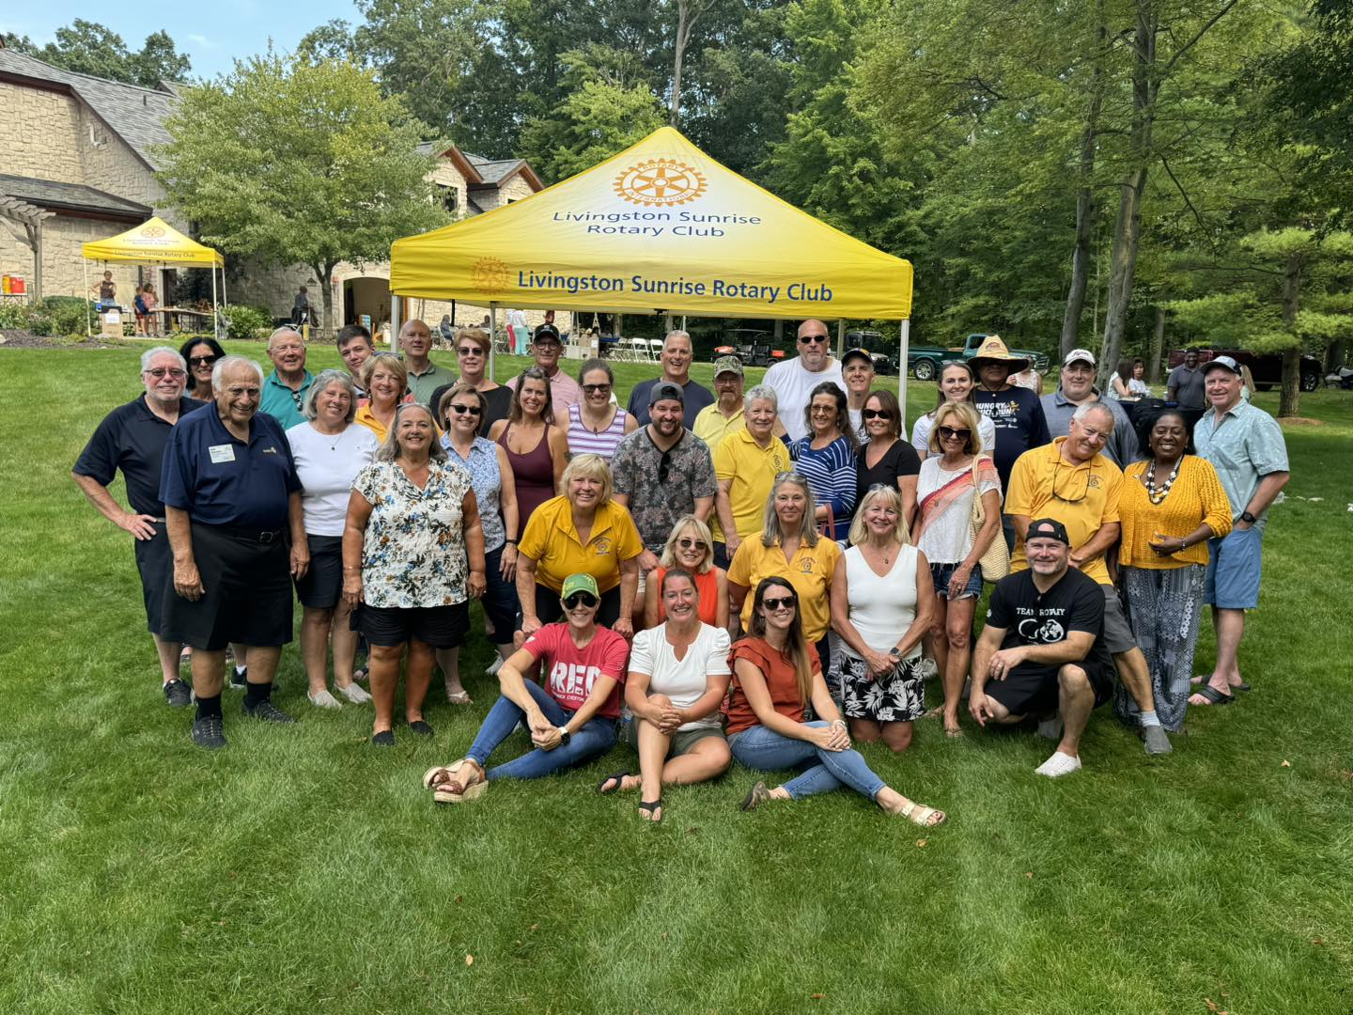

Photo Caption: Members of the Livingston Sunrise Rotary Club gather to celebrate their 20th anniversary at the Gronow residence in Howell, MI.

