**FOR IMMEDIATE RELEASE**

**Contact:**  
 Email: [info@rankmivote.org](mailto:info@rankmivote.org)  
 For more information: [RankMIVote.org](http://rankmivote.org)

**RANKED CHOICE VOTING TOWN HALL COMING TO HOWELL, MICHIGAN**

Livingston County residents have a unique opportunity to attend an upcoming Town Hall event focused on Ranked Choice Voting (RCV), a reform that could change the way voters in Michigan and across the nation participate in elections.

The town hall will take place on Wednesday December 18th at the Howell Library (Meabon Room), from 5:30 to 7pm, and is open to the public. This event aims to provide area residents with a clear understanding of how Ranked Choice Voting works, its potential benefits for Michigan’s elections, and how it could improve the overall voting experience.

Ranked Choice Voting is a voting method where voters rank candidates in order of preference, rather than selecting just one. If no candidate achieves a majority, the candidate with the fewest votes is eliminated, and votes are redistributed based on the next preference. This process continues until a candidate has a majority. Proponents of RCV argue that it can reduce negative campaigning, ensure more representative outcomes, and encourage a wider range of candidates to run for office.

**Key Details of the Event:**

* **Date:** Wednesday December 18th
* **Time:** 5:30 to 7pm
* **Location:** Howell Carnegie District Library, Meabon Room (enter from back of library)
* **Admission:** Free (registration encouraged; RSVP [here](https://secure.everyaction.com/a997s2bYMU6LqMmbaiaZww2))

At the Town Hall, participants will have the opportunity to:

* Learn about the problems with our current voting system
* Hear about an ambitious plan for a solution: ranked choice voting
* How ranked choice voting eliminates current election issues like “spoilers” and “lesser of two evils”
* Ask questions and voice opinions about how RCV could impact Michigan’s elections

"This is an opportunity for Howell residents to learn more about an important electoral reform and how it can empower voters and improve democracy," said Paul Giessner, a Howell-based volunteer with Rank MI Vote. "We encourage everyone to attend, whether they are already familiar with RCV or are just curious to learn more."

Attendees will also learn how RCV has been implemented in other parts of the country, its potential advantages for Michigan, and what the process to bring it to Michigan looks like.

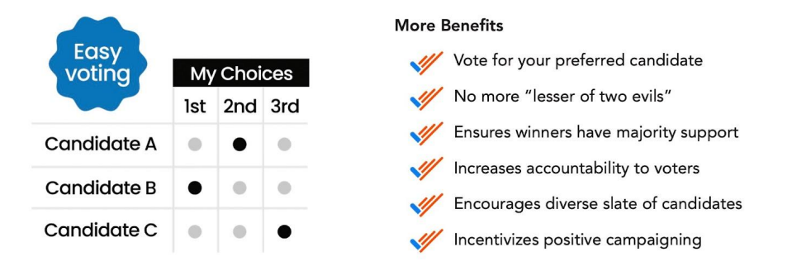

For more information, please email [info@rankmivote.org](mailto:info@rankmivote.org), or connect with Rank MI Vote on social media:  
 <https://www.facebook.com/RankMIVote>  
 <https://www.instagram.com/rankmivote/>  
 <https://x.com/rankmivote>

**About Rank MI Vote:**Rank MI Vote is a nonpartisan, nonprofit organization of volunteers working to promote the use of Ranked Choice Voting in Michigan.