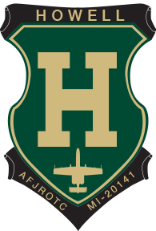
Sponsorship Registration Form
Hawk Meadows Golf Club
410 E. Marr Road, Howell, 48855

September 10, 2023

Please choose your sponsorship from the following:

- ½ Tee Box Sponsor - $125
- Full Tee Box Sponsor - $ 200
- Special Hole Sponsor - $250 (Hole 1 & 10)
- Breakfast Sponsor - $350
- Lunch Sponsor - $500

All sponsorships will be acknowledged at the outing, Facebook & on our website for the school year.
Thank you in advance for your help and support

-----------------------------------------------------------Please detach and return to address listed below----------------------------------------------------------------------

Cadet’s Name: ______________________________________________________________________

Sponsoring Company: ________________________________________________________________

Address: ___________________________________________________________________________

City/State/Zip: _______________________________________________________________________

Phone: ______________________________ Email: _______________________________________

Total Amount Enclosed: ________________ Type of Sponsorship ____________________________

Please make checks payable to:

Howell HS AFJROTC (Payments must be received by Sep 04, 2023)

And Mail to: Lisa Runyan
6236 Fonda Lake Drive
Brighton, MI 48116

Questions to howelljrotcgolf@gmail.com or (248) 431-2560

