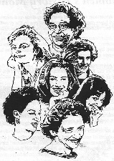The Joyce A. Powers Memorial Lecture
Sponsored by the Brighton Area Women’s History Roll of Honor

Tuesday, March 5, 7:00pm, Oak Pointe Country Club
Event is Free & Open to the Community
**Audience members encouraged to dress like Rosie the Riveter**

Featuring

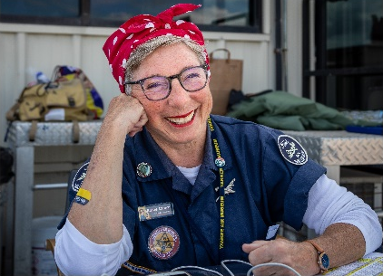

Claire Dahl, Yankee Air Museum

“The History of the Willow Run B-24 Bomber Plant,
the Legacy of Rosie the Riveter, & the
2023 Rosie Honor Flight to DC”

Announcing the 2024 Class of the Brighton Area Women’s History Roll of Honor

The 2024 honorees for the Brighton Area Women’s History Roll of Honor will be announced at the National Women’s History Month, Joyce A. Powers Memorial Lecture on March 5, 7:00pm, Oak Pointe Country Club, 4500 Club Drive, Brighton, MI 48116.

Dynamic, retired American History teacher Claire Dahl will share inspiring stories of Rosie the Riveter and the historic Willow Run B-24 Bomber Plant. Her presentation highlights the boldness, determination, creativity, and bravery of Americans as they prepared for, and then valiantly fought, World War II. Claire will cheer the dramatic and vital roles played by women as they showed the nation that they were willing and able to fill work force gaps. “We Can Do It” became the rallying cry for millions of women who had, until this time period, never envisioned working on an industrial assembly line building weapons of war.

Joyce A. Powers (1934-2022) moved to Brighton in 1967 and was a 25-year teacher and media specialist for Ann Arbor Public Schools. She served on the Brighton Board of Education four terms and was Board Secretary. Joyce exhibited a positive, can-do attitude throughout her life and frequently shared articles, books, and insights with others to spur examination and discussions. A lover of education, the arts, athletics, and the empowerment of women, Joyce co-founded the Brighton Area Women’s History Roll of Honor in 2003 to recognize the amazing accomplishments of area women. Her leadership, guidance, and passion for the Roll of Honor has blossomed into a current membership of 118 women from all walks of life. Joyce’s legacy is recognized through this second annual Joyce A. Powers Memorial Lecture sponsored by the Brighton Area Women’s History Roll of Honor.

